Ballyholme Yacht Club
Seacliff Road
Bangor
Co. Down,
BT20 5HT
Email: training@ballyholme.com

Ballyholme Yacht Club

Instructor Handbook
&
Operating Procedures
2022

Contents

Part A Instructor Handbook

Section | Title | Page
1 | Training at Ballyholme Yacht Club | 4
1.1 | Ballyholme Yacht Club as a Teaching Establishment | 4
1.2 | Information for Instructors | 5
1.3 | BYC Club Sailing Boats | 6
1.4 | BYC Windsurfers and Rigs | 7
1.5 | Training Ratios for RYA sailing courses, or any other tuition of novice sailors | 7
1.6 | Windsurfing Training | 7
1.7 | BYC Private Sailing Lessons | 8
1.8 | Safety provision for recreational dinghy sailing, which does not include any tuition, e.g. Social Sailing | 8
1.9 | Training Ratios for Powerboat Courses | 9
1.10 | Who teaches what in the RYA National and Youth Sailing Schemes | 9
1.11 | Who teaches what in the Windsurfing Scheme | 12
1.12 | Who teaches what in the Powerboat Scheme | 12
1.13 | BYC Sail Training Area | 14
1.14 | BYC Powerboat Training Area | 14
2 | Roles and Responsibilities | 15
2.1 | Course Preparation and Attendance Register | 15
2.2 | Course Shore Briefings and Sessions | 15
2.3 | Course Afloat Briefings and Sessions | 15
2.4 | Driving in the Club Grounds | 16
3 | BYC Safety Boats | 17
3.1 | BYC Safety Boat Pre-Launch Checklist | 17
3.2 | BYC Safety Boat Recovery Checklist | 17
3.3 | BYC RIB Safety Box contents | 17
3.4 | Safety Boat Maintenance | 18
3.5 | Safety Boat First Aid Kits | 18
4 | Safeguarding | 19
4.1 | BYC Designated Safeguarding Children’s Officers | 19
4.2 | BYC Safeguarding Policy | 19
4.3 | BYC Welfare Officer | 20
4.4 | Volunteers | 20
4.5 | Good practice | 20
4.6 | Raising Concerns | 20
Appendix A | Good Practice Guide - Hand-out for Instructors, Coaches and Volunteers | 21
Appendix B | What is child abuse? | 22
Appendix C | RYA NI Safeguarding and Child Protection Policy Statement | 26
5 | Emergency Procedures | 27
5.1 | Prior Planning | 27
5.2 | Emergency Procedures Ashore | 27
5.3 | Emergency Procedures Afloat | 30
5.4 | Dealing with a Major Incident | 30

Part B Operating Procedures

Section | Title | Page
1 | Statement of Principles | 32
2 | Responsibilities | 33
2.1 | General adherence to principles | 33
2.2 | Adherence to principles in the provision of RYA training | 33
2.3 | Provision of shore-based facilities and equipment | 33
2.4 | Planning of racing events and general organized afloat activities | 33
2.5 | Planning and organising of diving and related organised activities or procedures | 33
2.6 | Provision of rescue equipment and facilities | 33
2.7 | Other facilities, equipment and procedures | 33
3 | Persons at Risk | 34
3.1 | Those within the vicinity of BYC shore facilities | 34
3.2 | Those affected by activities afloat, organised by BYC | 34
4 | Identification of Hazards | 35
4.1 | Those within the vicinity of BYC shore facilities | 35
4.2 | Those affected by activities afloat, organised by BYC | 35
5 | Mitigation of Hazards | 36
5.1 | Those within the vicinity of BYC shore facilities | 36
5.2 | Those affected by activities afloat, organised by BYC | 39
6 | Operating Procedures | 42
6.1 | Safety equipment and inspections ashore | 42
6.2 | Safety equipment and inspections afloat | 42
6.3 | Generic course operating framework | 43
6.4 | Feedback procedure | 44
6.5 | Evacuation procedure | 46
6.6 | Emergency procedure ashore | 46
6.7 | Emergency procedure afloat | 46
6.8 | Safety boat operating procedures | 46
6.9 | Safety boat maintenance procedures | 48

Part A Instructor Handbook

1 Training at Ballyholme Yacht Club

a. Ballyholme Yacht Club's (BYC) main aim is to promote water-based activities to the community. As a Royal Yachting Association (RYA) Recognised Training Centre (RTC) and Champion Club, it is Ballyholme's purpose to develop skills in sailing, power boating, and other water sports.

b. BYC hosts other sailing organisations within its membership, such as Queen’s University Sailing Club and the Army Sailing Association NI. Any training taking place at BYC by these organisations is under the RTC and therefore iaw this handbook and club SOPs.

c. Its main aims are:

Introduce more people throughout the Borough to sailing, power boating and water-based activities.

To encourage young people through sport to develop both socially and improve sailing talent.

To develop links with schools, colleges, and youth organisations within the Ards and North Down Area.

Improve members' training in their chosen speciality.

To develop its sailing facilities to the benefit of its members and the people of Ards and North Down.

Improve our links with disabled and visually impaired sailing organisations.

To establish Ballyholme Yacht Club as a centre of sailing excellence not only in Ards and North Down Borough, but in the UK as a whole.

d. The members of Ballyholme Yacht Club (BYC) and its elected Flag Officers recognise that to achieve their 'vision' they must concentrate on promoting sailing; it is only through its membership and offering our training facilities to other organisations can it grow.

e. To this end it is recognised that we must organise, promote, and run professional training courses to introduce people to the sport. Sailing as a sport for all.

1.1 Ballyholme Yacht Club as a Teaching Establishment

- A recognised RYA Recognised Training Centre
- Qualified RYA Instructors.
- Worldwide recognised qualifications and training.
- A range of courses in Dinghies, Yachts, Windsurfers and Powerboats.
- RYA qualified rescue (safety) coxswains.
- Qualified first-aiders.
- A range of suitable training boats and boards.
- Excellent club facilities - training rooms, changing rooms, function rooms and bar.
- Safe slipways.
- Protected sailing area.
- Catering facilities.
- Large membership both at youth level and senior level.
- Ongoing sail training development.
- Excellent race programme.
- Junior and senior social programme.
- Extend water sports available as demand grows, following RYA or other national governing body guidance, as appropriate.

1.2 Information for Instructors

- Keys will be provided. If these are to be collected, they will be in an envelope with the Senior Instructor’s name on it in the member’s cabinet opposite the men’s changing rooms. Open the Club at 45 minutes before the course starts, i.e. 8.45am for a 9.30am start, unless otherwise arranged.

- The Executive Committee Member in charge of opening the club will open the Front door, Ladies and Gents changing rooms (inside and wet entrances), snug area and jubilee room and the galley if needed. The Senior Instructor keys will open the Cadet / Training Room, the Battery, the Rescue Shed (alarmed), the fuel store, and the compound.

- Try to keep wet clothing in Cadet Room to a minimum and use plastic seats. If students have dripping clothing, get them to rinse using the outside taps before entering via the changing rooms.

- Ensure that all equipment for Club boats and boards is accounted for and returned to the Training building as found.

- Safety Boats (RIBs) must be refuelled at the end of each day, especially Tuesday and Sunday during the summer season when they are used for club racing. The fuel store is attached to the training building on the roadside. The SI for the course will look after the keys.

- Be aware of any wake from large vessels in the Lough and high-speed vessels in the bay.

- Make sure no one is parked in the Emergency Access at any time during the course.

- Valuables can be secured in the safe in the Cadet Room during training. Lost property goes in the lost property box in the Drying Room and should be brought to the attention of the Senior Instructor.

- Ensure gear borrowed from the drying room (club wetsuits, buoyancy aids, helmets etc) is rinsed and returned at the end of each day.
- General waste and recycling waste bins are provided on site and within the Cadet Room.

- All course participants names, medical details and emergency contacts will be given to you prior to the course starting. Please ask students when they arrive about inhalers etc. that you might need to keep in a dry bag. Alert the Senior Instructor to any changes.

- Check that the club including changing rooms, Drying Room and Cadet Room are left tidy.

- Check that the dinghy parks are left tidy before you leave, and gates secure.

- Keys get returned to the bar upstairs or into the mailbox on the outside wall of the front of the club when the SI is finished with them.

- Wages will be paid directly into the instructor’s bank accounts and will be issued at the end of the month. A National Insurance number is required or an invoice to the club. You must give the Club Manager your bank details (name, account no and sort code). Invoices must be submitted by the 26th of each month.

- Read the attached copies of Health and Safety Policy, Child Protection Policy and BYC Instructor Procedures for courses.

1.3 BYC Club Sailing Boats

Laser Picos (12 boats)
- masts with sails rolled around them in Rescue Building on the rack to the right of the right-hand shuttered entrance
- rudders and centre boards secured in the boats
- boats stored in racks and to right hand side in the rescue Building (bow first)
- Jibs available in the rescue building at the end of the racks hanging up on a rail
- There are 6 picos with helmets in them (Numbered as the boats are, 1-6)
- Picos that shouldn’t be used are labelled with ‘DO NOT USE’ and may have yellow and black tape affixed.

Bahias (4 boats)
- Sails stay on the boats (Spinnaker in Portacabin unless continually in use)
- rudders (and centre boards) stay in the boats
- boats stored in North Park or compound
- halyards should be secured so as not to end up at top of mast
- covers put on and secured after use

RS Quests (2 boats)
- Sails stay on the boats (Spinnaker in Portacabin unless continually in use)
- rudders (and centre boards) stay in the boats
- boats stored in North Park or compound
- halyards should be secured so as not to end up at top of mast
- covers put on and secured after use

RS Fevas (3 boats)
- Sails stay on the boats (Kevlar sails stay in the rescue shed or portacabin)
- rudders and centre boards stay in the boats
- boats stored by the rescue shed
- halyards should be secured so as not to end up at top of mast

Sail Qubes (9 boats)
- Sails stay on the masts (in the rescue shed), or in the boat at lessees’ risk outside
- rudders and centre boards stay in the boats
- boats stored in the rescue shed, unless leased when they must be outside and covered

Toppers (3 boats)
- Sails stay on the boats
- rudders and centre boards stay in the boats
- boats stored in the dinghy Park

Lasers (1 boat)
- Sails stay in the portacabin unless leased
- rudders and centre boards stay in the boats (unless leased)
- boats stored outside in the dinghy park
Tool Kit
- The tool kit and spares are in the Training Portacabin
- The kit for boats that aren’t in use stays in the Rescue Shed or Training Portacabin
- All topper kit including extra covers is the responsibility of the lessee
- Only BYC staff, committee and instructors should go in the Rescue Shed

1.4 BYC Windsurfers and Rigs

HiFly Motion (3)
- Fins remain attached (to be checked before each course for security)
- Daggerboard remains fitted (operability to be checked before each course)
- UJs to be kept separately on ‘peg board’

Naish Scout 4.5m Rig
- Boom to be detached and stored separately
- Downhaul tension to be checked prior to use
- Downhaul rope to be replaced each season
- Booms to be treated with WD40 regularly and metal fittings inspected for corrosion
- Sail to be inspected regularly for integrity

RED 10’7 WindSUPs (4) (delivery date tbc)
- Boards to remain inflated during training season (inflation checked prior to course)

RED 3.5m and 2.5m Rigs (delivery date tbc)
- Boom to be detached and stored separately
- Downhaul tension to be checked prior to use
- Downhaul rope to be replaced each season
- Booms to be treated with WD40 regularly and metal fittings inspected for corrosion
- Sail to be inspected regularly for integrity

1.5 Training Ratios for RYA sailing courses, or any other tuition of novice sailors

Safety craft
1 Safety Boat: 1-6 dinghies / windsurfers

2 Safety Boats: 7-15 dinghies / windsurfers

3+ Safety Boats: 15+ dinghies / windsurfers

Instructors Sailing
Crewed Dinghies 3:1 for beginners with instructor onboard
Maximum 9:1 but not more than 6 boats per instructor (e.g. 3 Bahias with 3 students in each, or 4 Picos with 2 students in each)

Single handed 6:1 (applies only whilst the boats are used as single handers)

Windsurfers 6:1 (instructor on a windsurfer or in Safety Boat)

1.6 Windsurfing Training

a. Windsurfing training is new to BYC in late 2022. All Start Windsurfing Training should follow the current RYA Start Windsurfing Teaching System W4a. During initial courses, separate rescue cover is to be provided, whilst also complying with the instructor to student teaching ratio.
b. The minimum qualification for teaching Start Windsurfing or Youth Stage 1/2 courses is a Start Windsurfing Instructor certificate.

c. Use of a Simulator - During a Start Windsurfing course, gybing is to be demonstrated only by the instructor. On any Youth course, no child (under 16) may use the simulator.

d. Instructors are to read the Windsurfing-specific Risk Assessment prior to delivering a Start Windsurfing or Youth Stage 1/2 course.

e. On-water tuition for Start Windsurfing should be 6 hrs minimum for instructor to student ratios of up to 1:3, and 8 hrs for 1:4 and above.

f. No more than 50% of boards used for a course may be WindSUPs.

1.7 BYC Private Sailing Lessons

a. The instructor must be a full RYA Dinghy Instructor (DI) and member of Ballyholme Yacht Club. Lessons only can occur when there is BYC Rescue Cover and a Senior Instructor on site who is aware that the lesson is going on and is ready at any time to assist if necessary. The DI is to tell the Race Officer (if applicable) or rescue crews that a lesson is taking place and must brief the SI on duty before going afloat. On some occasions when the lesson is in a Pico the instructor will take a RIB (or Yak if sufficient people are available to launch and recover). If the lesson is on a double handed boat, instructor and student in the boat, a Safety Boat can remain tied to the jetty with SI on the radio to assist if needed. The DI must carry a hand-held VHF radio and know how to use it.

b. Private Lessons may occur during Social Sailing hours or during Autumn Training when the Safety Boat is out. There must always be an instructor with the student.

1.8 Safety provision for recreational sailing, which does not include any tuition, e.g. Social Sailing

- At least one Safety Boat must be provided per group. It is recommended that each Safety Boat must provide cover for no more than 12 dinghies / windsurfers / windsurfers. It is recommended that there is room in the Safety Boat (s) for all those afloat to be recovered should all boats/boards be abandoned. Radios should be carried on the instructor’s body in the yaks. There are radios installed in the RIBs that should be used. It is recommended RIBs are used when the wind is northerly and 15+ knots.

- Social Sailing – this is NOT part of BYC Training and is run separately by the Sailing Committee. Those running Social Sailing must ensure there is sufficient Safety Boat cover available for the number of participants on the water.

- Dolphins and Sharks – this is run by separately by a team of parents. Operations must adhere to Standard Procedures. If swimming is involved, then ratios of parent / instructors to children in the water is 1:5 minimum. The parent team that are allocated to be present by a rota system must be onsite and involved. The team should be located in the North Park in the shed, in between parks, on the South Slip, in the Cadet Room and, in and on the water. Those driving Safety Boats need to be minimum PB L2 qualified and must be full BYC members.
- Sufficient Safety Boats must be available to provide separate cover for all courses in progress at any one time. It is not acceptable to expect the instructors teaching a basic skills course to also provide safety cover for other groups on the water. For more advanced courses the Safety Boat may be staffed by a helm holding a Safety Boat certificate, together with the Instructor leading the session. Should a Safety Boat be launched for a given number of dinghies during social sailing, the crew of the boats that turn up after the ratio is reached must be informed.

1.9 Training Ratios for Powerboat Courses

Level 1 and 2 1 Instructor: 3 Students / 1 Boat
Safety Boat and Advanced 1 Instructor: 6 Students / 2 Boats

For dinghy and powerboat courses up to 50% of helpers assisting an Instructor may be unqualified, but must be experienced and competent. They will only be allowed to assist at the discretion of the Powerboat Instructor running the course.

1.10 Who teaches what in the RYA Adult and Youth Sailing Schemes

Instructor / Coach | Youth Sailing Scheme | Adult Sailing Scheme
Dinghy Instructor | Stages 1, 2, 3 & 4  Advanced modules as per the NSS | Sailing Scheme Levels 1, 2 and 3, Day Sailing, Seamanship Skills and Sailing with Spinnakers (if suitably experienced and approved by the Principal or Chief Instructor)
Racing Instructor | Stages 1, 2, 3 & 4  Advanced modules as per the NSS | Club Racing, Sailing Scheme Levels 1, 2 and 3, Day Sailing, Seamanship Skills and Sailing with Spinnakers (if suitably experienced and approved by the Principal or Chief Instructor)
Advanced Instructor | Stages 1, 2, 3 & 4  Advanced modules | Start Sailing, Basic Skills, Seamanship  Skills, Day Sailing, Sailing with Spinnakers,  Performance Sailing
Level 2 Race Coach |  | Club Racing, Regional Racing (at an RYA Training Centre)
Level 3 Race Coach |  | Club Racing, Regional Racing and Championship Racing (at an RYA Training Centre)

* Instructor who is experienced with spinnakers and approved by the Principal or Chief Instructor.
** All RYA tuition must be supervised by a Senior Instructor.
- An assistant instructor counts as qualified in the ratios but should work under the direction or supervision of an instructor or SI.
- A Senior Instructor may be assisted by 50% experienced but unqualified sailors.

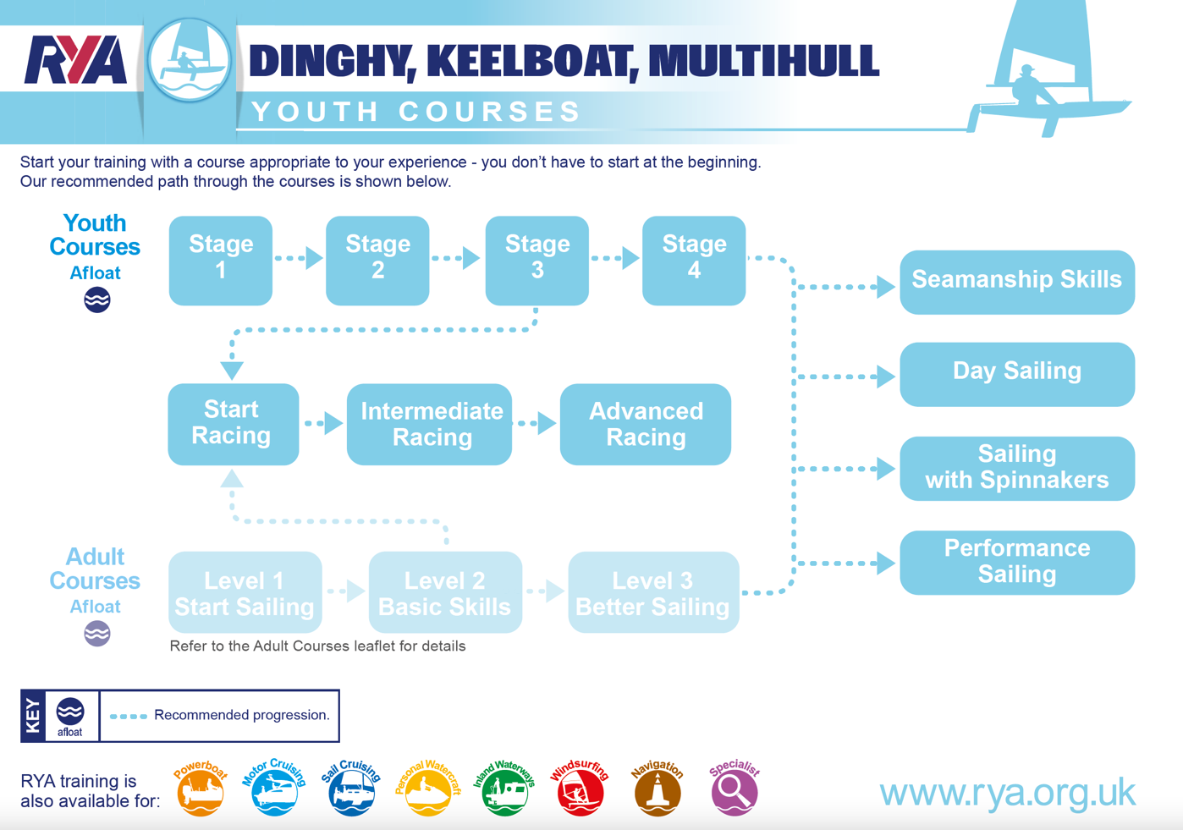

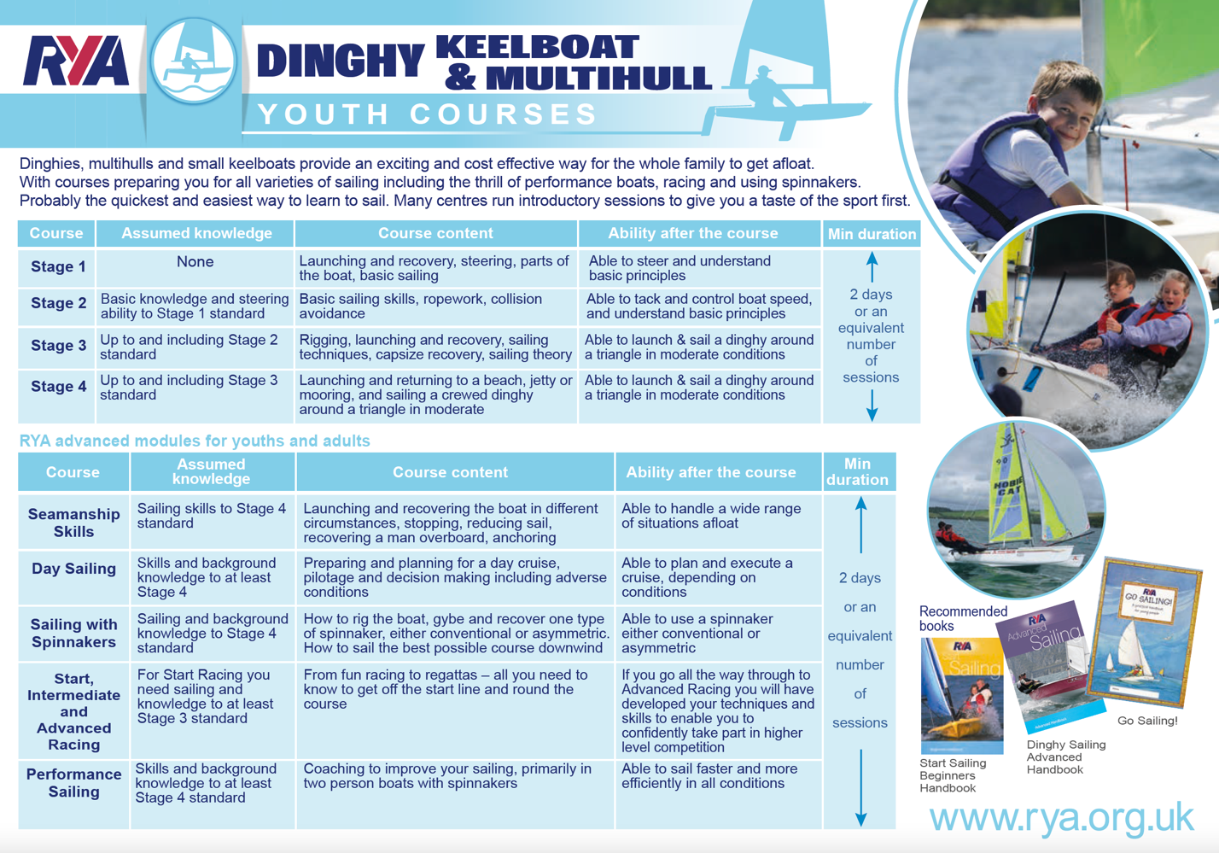

RYA Youth Dinghy Courses
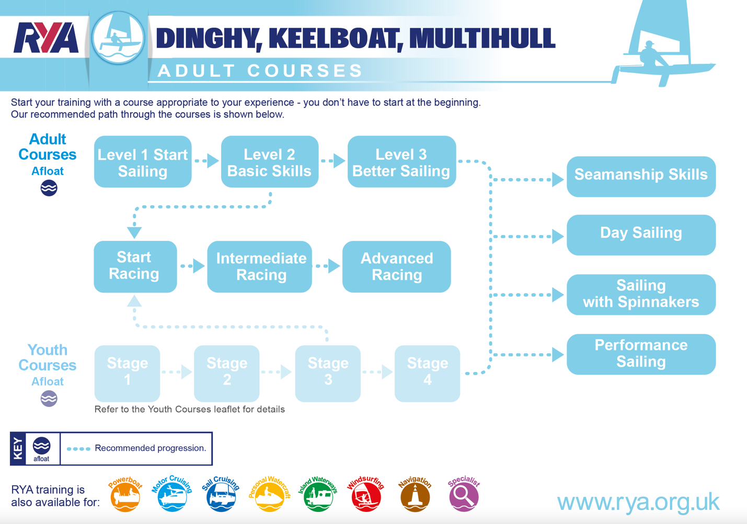

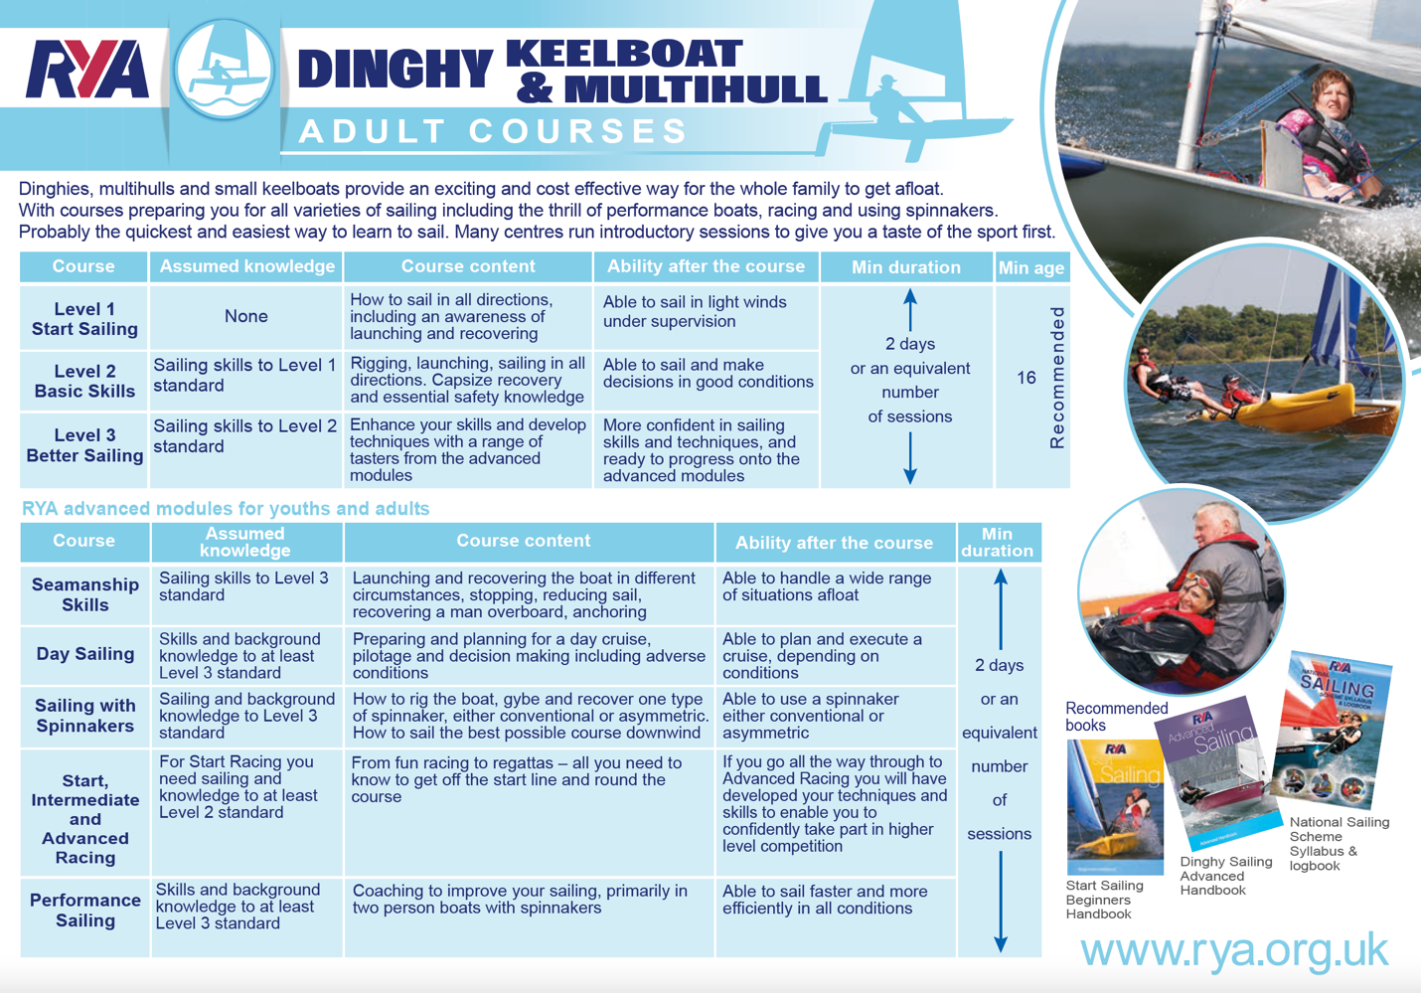

RYA Adult Dinghy Courses

1.11 Who teaches what in the Windsurfing Scheme

The following table details of the minimum instructor qualifications required for each level of course, working with supervision.
Courses | Qualification
Youth Windsurfing Stage 1 and 2;  Start Windsurfing | Start Windsurfing Instructor
Youth Windsurfing Stage 3;  Intermediate non-planing | Intermediate non-planing instructor  The beach starting, harnessing, and tacking elements only may be delivered by a Start Windsurfing Instructor who is suitably experienced and approved by the Principal or Chief Windsurfing Instructor
Youth Windsurfing Stage 4;  Intermediate planing | Intermediate planing instructor  The beach starting, harnessing, and tacking elements only may be delivered by a Start Windsurfing Instructor who is suitably experienced and approved by the Principal or Chief Windsurfing Instructor
Advanced | Advanced Windsurfing Instructor
Start Racing | Racing Instructor (windsurfing)
Intermediate Racing | Racing Coach Level 2 or Racing Instructor who is also suitably experienced and approved by the Principal or Chief Instructor.
Advanced Racing | Racing Coach Level 3, or a Racing Instructor/Racing Coach Level 2 who is suitably experienced and approved by the Principal or Chief Instructor
Foiling | Foiling Instructor. For Sustained Flight courses and above, the Foiling Instructor must be suitably experienced and approved by Principal or Chief Instructor.

1.12 Who teaches what in the Powerboat Scheme

Instructors Qualification | Qualified to Teach
Powerboat Instructor with  Coastal Endorsement | Levels 1 and 2  (Inland & Coastal)
Powerboat Instructor with  Safety Boat & Coastal  Endorsement | Levels 1 and 2 plus Safety Boat (Inland & Coastal)
Advanced Powerboat Instructor * | Levels 1 and 2, (Inland & Coastal) Intermediate and Advanced (Coastal Only)
Advanced Powerboat Instructor  with Safety Boat * | Levels 1 and 2, Safety Boat (Inland & Coastal) Intermediate and Advanced (Coastal Only)
Powerboat Trainer * ** | Levels 1 and 2, Safety Boat (Inland & Coastal) Intermediate, Advanced and Instructor Training Courses

* Only instructors qualification marked * can carry out own boat tuition when it is away from your Training Centre base.
** Instructor Training Courses may only be carried out with the knowledge and permission of the RYA Regional Coach and must have a moderator.

BYC only teaches RYA Powerboat Level 2 and Safety Boat.

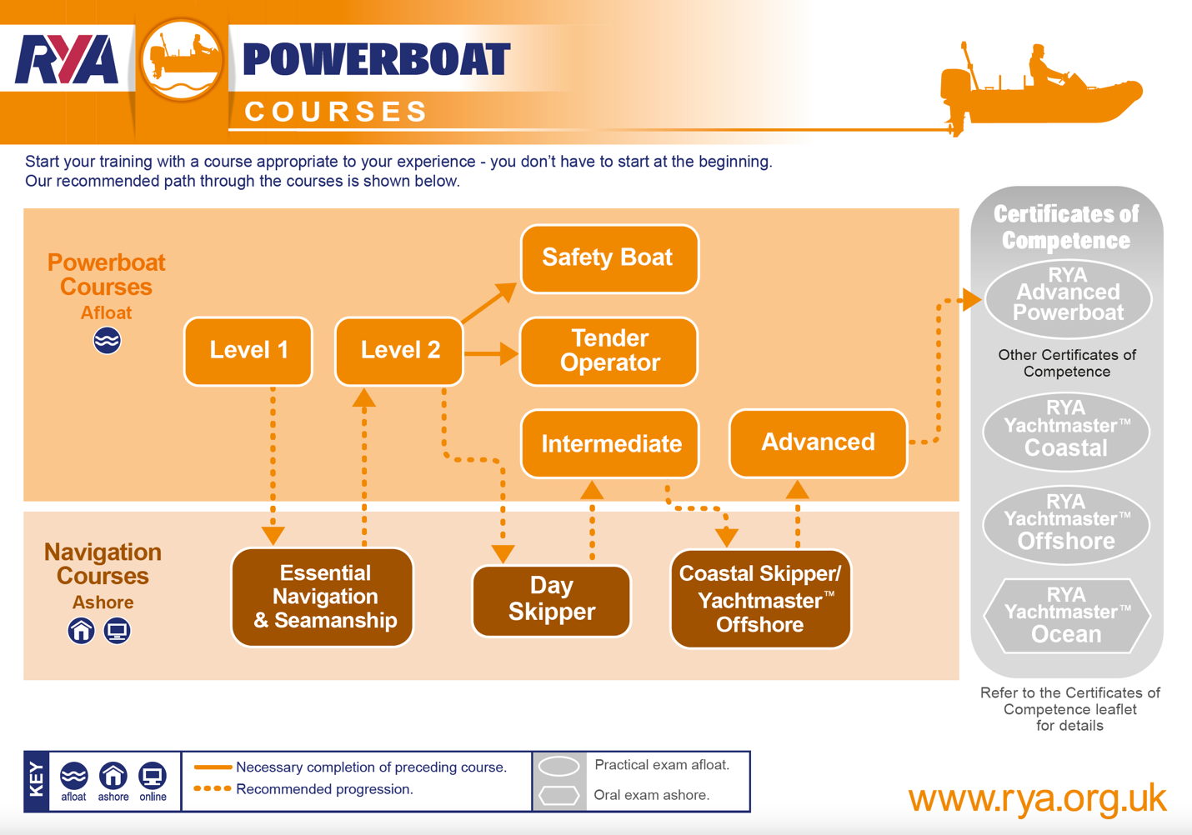

RYA Powerboat Courses

1.13 BYC Sail Training Area
This applies to dinghy and windsurfing training. Start Windsurfing training should take place no further north than the northerly extent of the club, and a line drawn parallel to the mouth of the bay (red dotted line).

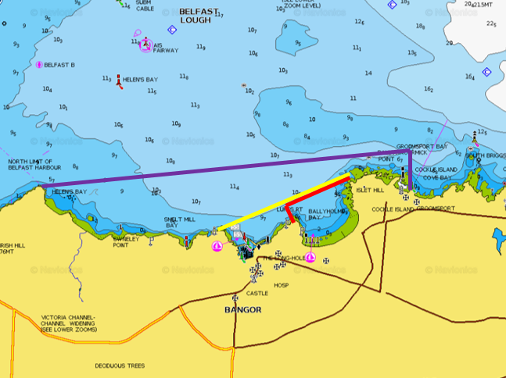
BYC sail training area within red box
Hire Limit within yellow box
Day sailing area within purple box

1.14 BYC Powerboat Training Area

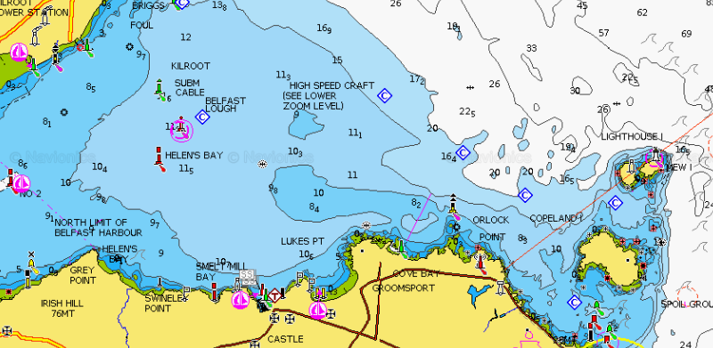
Area extends to Grey Point, out to the Fairway Buoy and SE to South Briggs, and to Orlock Point.
2 Roles and Responsibilities

2.1 Course Preparation and Attendance Register
a. The Senior Instructor (SI) shall assume responsibility for all matters of forward planning for the course including the BYC Health and Safety Policy. Requirements of other instructors and Safety Boat cover shall be determined and recorded prior to the start of the course. All attendees shall provide information on medical conditions and shore contacts as part of registration for the course. The SI before the start of the course must review this. Any special arrangements or provisions must be briefed to all instructors, assistant instructors, and safety crew. Course registration is available online at:
http://www.ballyholme.com

b. In a UK RTC, provided the Chief Instructor is completely confident that standards of safety and tuition will be maintained on the day, they may occasionally delegate a single group to a suitably trained and experienced instructor. This instructor must have been trained in the procedures at the site and be competent to run the session. However, an SI should be on site when a centre is running more than one sailing and / or windsurfing group simultaneously.

2.2 Course Shore Briefings and Sessions
a. An initial shore safety briefing shall be provided to all course attendees at the start of the first session. These briefings must include:
- Current and expected weather conditions.
- Provision of suitable club clothing, and helmets for Pico helms no. 1-6 (if the SI decides they are necessary).
- Allocation of boats and crews, or boards, preferably documented on white boards.
- Fire alarms, fire exits, procedures, and availability of First Aid.
- Tripping and slipping hazards in the boat parks (chains), on slipways and jetties (buoyancy aids must be worn on slipways and jetty).
- Risks from the wash of high-speed craft.
- Risks from vehicle movements in the boat parks.
- Risks from departing the Club (main road): all youths to stay on-site.
- Risks from marine engines.
- Use of personal buoyancy. (BYC can provide lifejackets / buoyancy aids from Drying Room if required.)
- Use of rails and drying room for hanging club sailing kit to dry.
- Provision of suitable personal clothing.
- BYC Operating area off the road away from the water edge unless launching / recovering.
- Any specific additional risks identified (eg holes in concrete or slipway).
- Muster area for fire or alarm is in the South Park if based in the Cadet Room. This is denoted by a green sign.
- Use of windsurfing simulator (if applicable).

2.3 Course Afloat Briefings and Sessions
a. An additional briefing shall be provided immediately prior to going afloat. Considerations should include:
- The sailing area.
- Likelihood of abandonment or cancellation.
- Method of being accounted for on return to the shore.
- Safety cover.
- Launch / recovery is normally easiest from the South Slip. Note: in a sailable north-easterly breeze care needs to be taken recovering as there may be a bigger than normal swell, particularly at low water.
- Method of indicating return ashore and other safety signals (see below).
b. All afloat instructors and safety crew shall also be briefed in methods of communication with the SI, and requirement for reporting deteriorating conditions.

2.4 Driving in the Club Grounds

a. During courses, Instructors must remain vigilant on the club premises. Gates to the dinghy parks should always remain closed and vehicles on site should be minimal.

b. Instructors must try and identify anybody they see driving dangerously in the parks. Try to obtain the make, model, and registration of car (though any element will do). This should then be forwarded to the RTC Principal (along with a description of the incident) and the Training Committee will follow up.

3 BYC Safety Boats

3.1 BYC Safety Boat Pre-Launch Checklist

a. The following are to be checked before launch:

- Condition of trailer & tyres.
- Condition of hull, console, seats, and tubes.
- Tubes adequately inflated.
- Oil level.
- Fuel level.
- Safety Box / bag dry, complete and on board.
- Anchor and warp (n.b. there are extra anchors with training buoys attached for training – these should be carefully taken from and returned to the compound and not left in the Safety Boats unless in the yaks).
- Bailer or Bucket onboard.
- Pump or bellows stowed onboard.
- Kill cord - test after engine run (spare to be in safety box).
- VHF radio or handheld checked and stowed securely.

3.2 BYC Safety Boat Recovery Checklist

a. The following are to be adhered to before recovery:

- Stay afloat until last course participant is ashore.
- Moor boat sufficiently far down to avoid damaging by swinging under the jetty.
- Retrieve with engine partially raised to avoid a prop strike.
- Wash down, clean and remove any rubbish.
- Waterproof Safety Bag / Box: check dry and complete, then return to Battery / Cadet Room.
- Faults are to be recorded on whiteboard in Cadet Room. The SI in charge is to tell the Rescue Convenor.

3.3 BYC RIB Safety Box contents:

- Spare Kill Cord
- Spare Starting Cord
- Basic Tool Kit
- Knife
- Compass
- Survival Bag/Thermal Protective Aid
- Flares
- First Aid Kit (Waterproof):
  - 2 Large Wound Dressings
  - 2 Medium Wound Dressings
  - Triangular Bandages.
- Distress flares – 2 orange smoke and 2 day/night flares.
See also BYC SOPs.

3.4 Safety Boat Maintenance

a. The maintenance of BYC Safety Boats shall adhere to the following guidelines:

- Safety Boat engines shall be serviced by a designated specialist at least once per season.

- Records of services shall be held both by the specialist and BYC (Rescue Convenor).

- Safety Boats shall be returned to the specialist if any significant problems are found or reported.

- Safety Boat kill cords shall be tested for safe operation and condition on each occasion before the boat is used.

- Safety Boat VHF radios shall be checked for correct operation on each occasion before the boat is used.

- Safety Boat hulls, collars shall be thoroughly checked for condition twice per season.

- Safety Boats engine oil levels and quality shall be checked regularly.

- Safety Boat propellers shall be checked and if necessary, returned to the designated specialist for repair or replacement regularly.

- Safety Boats shall be launched and tested for safe and correct regularly by the Rescue Convenor or Safety Boat maintenance personnel.

- Waterproof safety bags / boxes shall be checked to be dry and complete regularly.

- Any problems or faults recorded on the whiteboards, or related directly to the Rescue Convenor or Safety Boat maintenance personnel, shall be acted on prior to the next planned use of the boat, either by rectification, return to the designated specialist or by clearly marking the boat as "Out of Service" with a suitable label mechanism e.g. Out Of Service wheel-cover, prop-bag or hazard tape across the console.

3.5 Safety Boat First Aid Kits

a. RIBs have slightly differing kits than Yaks, with the kits for the RIBs being more comprehensive. There are also kits in the Rescue Shed, Office, Galley, Cadet Room, and Bar. A full list of items for each list can be obtained from the Principal or Rescue Convenor. See also BYC SOPs.

b. All instructors and course attendees shall be made aware of available First Aiders and location of the First Aid kits.

4 Safeguarding

4.1 BYC Designated Safeguarding Children’s Officers

Aidan Pounder 028 91271467 (Club Welfare Officer)
Sarah Jane Flannigan 028 91472467
Rob Milligan 07973 371792 (RTC lead)

4.2 BYC Safeguarding Policy

a. It is the policy of Ballyholme Yacht Club to safeguard children and vulnerable adults from physical, sexual, or emotional harm. BYC will take all reasonable steps to ensure that, through appropriate procedures and training, children participating in BYC activities do so in a safe environment. We recognise that the safety and welfare of the child is paramount and that all children, whatever their age, gender, disability, culture, ethnic origin, colour, religion or belief, social status, or sexual identity, have a right to protection from abuse.

In the context of this policy, ‘child’ refers to any young person under the age of 18. The policy also covers ‘vulnerable adults’, such as people with learning difficulties, or who have difficulty communicating, or who rely on others to provide personal care.

b. BYC actively seeks to:
- Create a safe and welcoming environment, both on and off the water, where children can have fun and develop their skills and confidence.
- Recognise that safeguarding children is the responsibility of everyone, not just those who work with children.
- Ensure that organised club training and events are run to the highest possible safety standards.
- Be prepared to review club ways of working to incorporate best practice.

c. We will:

- Treat all children with respect and celebrate their achievements.
- Carefully recruit and select all employees, contractors, and volunteers.
- Respond swiftly and appropriately to all complaints and concerns about poor practice or suspected or actual child abuse.

d. This policy relates to all employees, contractors and volunteers who work with children or vulnerable adults, in the course of their BYC duties. It will be kept under periodic review. All relevant concerns, allegations, complaints, and their outcome should be notified to the BYC Welfare Officer.

4.3 BYC Welfare Officer

a. The Club Welfare Officer is the lead Designated Safeguarding Children’s Officer and is responsible for acting as a voice for safeguarding within BYC, working with the committee to ensure best practice is adhered to and to coordinate actions within the club, should a concern or referral arise. It is important that the Club Welfare Officer is well known within the club and all members should have the contact details of the dedicated Club Welfare Officer. They should not be a member or related to a member of the coaching team and must be over the age of 18.

b. The Club Welfare Officer is to:
- Provide guidance on safeguarding child / adults protection within the club and ensure that it remains high on the committee’s agenda
- Ensure that the club has an up-to-date Safeguarding and Bullying and Harassment policies which are in line with the RYA’s
- Promote the clubs Code of Conduct
- To implement safe recruitment processes and procedures
- Support the Lead Signatory for disclosure checks when required
- Be willing to undertake an enhanced disclosure for your role as Club Welfare Officer. These are free for volunteers.
c. BYC Welfare Officer is Aidan Pounder.

4.4 Volunteers

All Club volunteers whose role brings them into contact with young people will be asked to provide references or to complete a self-disclosure form. Those instructing, coaching, or supervising young people will also be asked to apply for an Access NI criminal record check, which should be renewed every 3 years, but must be renewed every 5 years.

4.5 Good Practice

a. All members of the Club should follow the good practice guidelines (Appendix A).
Those working with young people should be aware of the guidance on recognising abuse (Appendix B).

b. All BYC Instructors are to have completed the RYA Safe and Fun online course. This should be renewed every 3 years but must be renewed every 5 years.

c. The Club will seek written consent from the child and their parents / carers before taking photos or video at an event or training session or publishing such images. Parents and spectators should be prepared to identify themselves if requested and state their purpose for photography / filming. If the Club publishes images of children, no identifying information other than names will be included. Any concerns about inappropriate or intrusive photography or the inappropriate use of images should be reported to the Club’s Welfare Officer.

4.6 Raising Concerns

a. Anyone who is concerned about a young member’s welfare, either outside the sport or within the Club, should inform the BYC Child Protection Officers immediately, in strict confidence. The BYC Child Protection Officers will follow the attached procedures (see Flowcharts 1 and 2).

b Any member of the Club failing to comply with the Child Protection policy may be subject to disciplinary action under Club Rule 28.
Appendix A - Good Practice Guide

Hand-out for Instructors, Coaches and Volunteers

This guide only covers the essential points of good practice when working with children and young people. You should also read BYC’s Child Protection Policy and Procedures, which are always available for reference.

- Avoid spending any significant time working with children in isolation.
- Do not take children alone in a car, however short the journey.
- Do not take children to your home as part of your organisation’s activity.
- Where any of these are unavoidable, ensure that they only occur with the full knowledge and consent of someone in charge of the organisation or the child’s parents.
- Instructors and helpers on a course should avoid showering alone with youths. If possible, time other duties like RIB recovery or returning dinghies to their storage area.
- Design training programmes that are within the ability of the individual child.
- If a child is having difficulty with a wetsuit or buoyancy aid, ask them to ask a friend to help, if at all possible.
- If you have to help a child, make sure you are in full view of others, preferably another adult.

You should never:
- engage in rough, physical, or sexually provocative games.
- allow or engage in inappropriate touching of any form.
- allow children to use inappropriate language unchallenged or use such language yourself when with children.
- make sexually suggestive comments to a child, even in fun.
- fail to respond to an allegation made by a child; always act.
- do things of a personal nature that children can do for themselves.

It may sometimes be necessary to do things of a personal nature for children, particularly if they are very young or disabled. These tasks should only be carried out with the full understanding and consent of the child (where possible) and their parents/carers. In an emergency that requires this type of help, parents should be fully informed. In such situations it is important to ensure that any adult present is sensitive to the child and undertakes personal care tasks with the utmost discretion.

Appendix B – What is child abuse?

Abuse and neglect are forms of maltreatment of a child. Somebody may abuse or neglect a child by inflicting harm, or by failing to act to prevent harm. Children may be abused in a family or in an institutional or community setting, by those known to them or, more rarely, by a stranger. They may be abused by an adult or adults, or another child or children.

Physical abuse may involve adults or other children causing physical harm:
- by hitting, shaking, squeezing, biting, or burning
- giving children alcohol, inappropriate drugs, or poison
- attempting to suffocate or drown children
- in sport situations, physical abuse might also occur when the nature and intensity of training exceeds the capacity of the child’s immature and growing body.

Neglect is the persistent failure to meet a child’s basic physical and/or psychological needs, likely to result in the serious impairment of the child’s health or development. Neglect may involve a parent or carer failing to:
- provide adequate food, clothing, and shelter
- protect a child from physical and emotional harm or danger
- ensure adequate supervision
- ensure access to appropriate medical care or treatment
- respond to a child’s basic emotional needs
- neglect in a sailing situation might occur if an instructor or coach fails to ensure that children are safe or exposes them to undue cold or risk of injury.

Sexual abuse. Sexual abuse involves an individual forcing or enticing a child or young person to take part in sexual activities, whether the child is aware of what is happening, to meet their own sexual needs. The activities may involve:
- physical contact (eg. full sexual intercourse, masturbation, oral sex, fondling)
- showing children pornographic books, photographs, videos, or online images
- taking pictures of children for pornographic purposes
- encouraging children to behave in sexually inappropriate ways
- sport situations which involve physical contact (e.g. supporting or guiding children) could potentially create situations where sexual abuse may go unnoticed. Abusive situations may also occur if adults misuse their power over young people.

Emotional abuse is the persistent emotional maltreatment of a child such as to cause severe and persistent adverse effects on the child’s emotional development. It may involve:
- conveying to children that they are worthless, unloved, or inadequate
- not giving the child opportunities to express their views, deliberately silencing them or ‘making fun’ of what they say or how they communicate
- imposing expectations which are beyond the child’s age or developmental capability
- overprotection and limitation of exploration and learning
- preventing the child from participating in normal social interaction
- serious bullying (including cyberbullying), causing children frequently to feel frightened or in danger
- the exploitation or corruption of children
- emotional abuse in sport might also include situations where parents or a coach subject a child to constant criticism, bullying or pressure to perform at a level that the child cannot realistically be expected to achieve.
Some level of emotional abuse is involved in all types of maltreatment of a child.

Bullying (including cyberbullying) may be seen as deliberately hurtful behaviour, usually repeated, or sustained over a period of time, where it is difficult for those being bullied to defend themselves. The bully may often be another young person. Although anyone can be the target of bullying, victims are typically shy, sensitive, and perhaps anxious or insecure. Sometimes they are singled out for physical reasons – being overweight, physically small, having a disability or belonging to a different race, faith, or culture.

Recognising Abuse
It is not always easy, even for the most experienced carers, to spot when a child has been abused. However, some of the more typical symptoms which should trigger your suspicions would include:
- unexplained or suspicious injuries such as bruising, cuts or burns, particularly if situated on a part of the body not normally prone to such injuries.
- sexually explicit language or actions.
- a sudden change in behaviour (e.g. becoming very quiet, withdrawn or displaying sudden outbursts of temper)
- the child describes what appears to be an abusive act involving him / her.
- a change observed over a long period of time (e.g. the child losing weight or becoming increasingly dirty or unkempt)
- a general distrust and avoidance of adults, especially those with whom a close relationship would be expected
- an unexpected reaction to normal physical contact
- difficulty in making friends or abnormal restrictions on socialising with others.

It is important to note that a child could be displaying some or all of these signs, or behaving in a way which is worrying, without this necessarily meaning that the child is being abused. Similarly, there may not be any signs, but you may just feel that something is wrong. If you have noticed a change in the child’s behaviour, first talk to the parents or carers. It may be that something has happened, such as a bereavement, which has caused the child to be unhappy.

If you are concerned
If there are concerns about sexual abuse or violence in the home, talking to the parents or carers might put the child at greater risk. If you cannot talk to the parents/carers, consult BYC’s Welfare Officer or the person in charge. It is this person’s responsibility to make the decision to contact Children’s Social Care Services or the Police. It is NOT their responsibility to decide if abuse is taking place, BUT it is their responsibility to act on your concerns.

Appendix B Flowchart 1 and 2

Flowchart 1
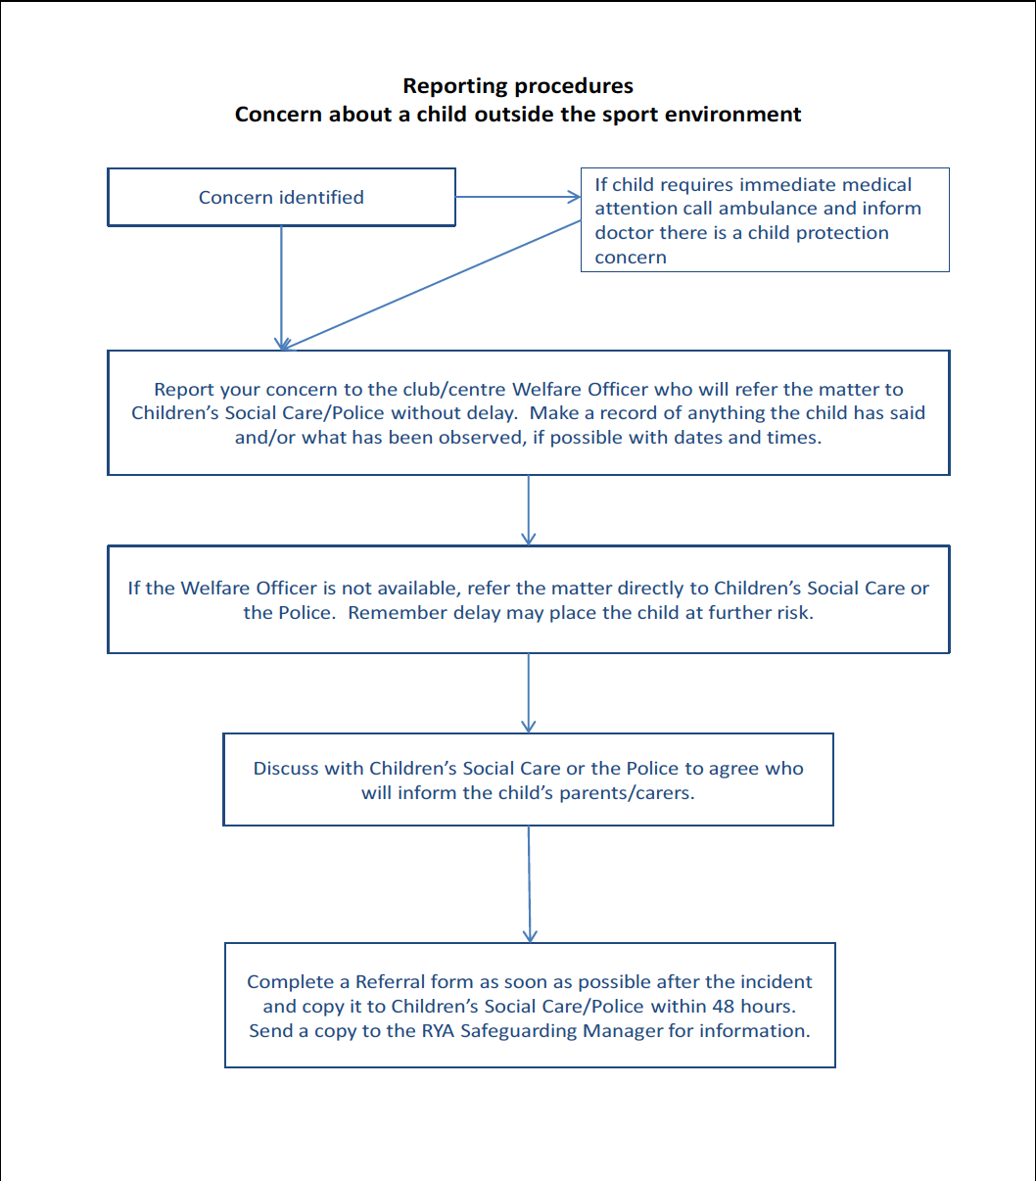

If you are uncertain what to do at any stage, contact the RYA-NI Child Protection Officer Cliff Burns (or Gayle Logan) on
028 9038 3812, or the RYA-UK Child Protection Co-ordinator Jackie Reid on 023 8060 4104, or the NSPCC free 24-hour helpline 0808 800 5000.

Flowchart 2

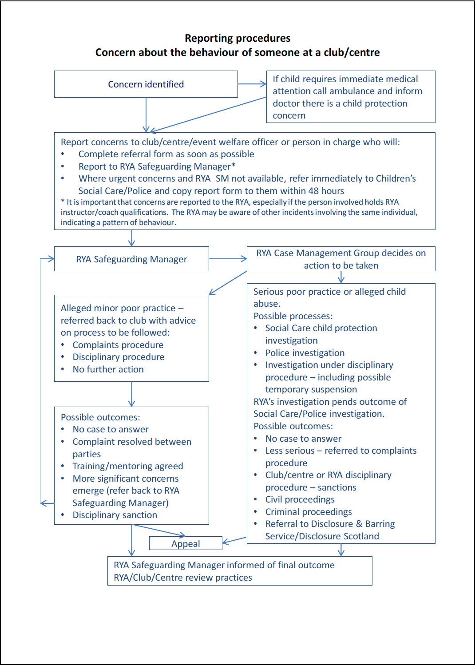
Appendix C – RYA Northern Ireland’s Safeguarding and Child Protection Policy Statement
Revised Nov 2016
As defined by the Children Act 1989, for the purposes of this policy anyone under the age of 18 should be considered as a child. The policy applies to all RYA Northern Ireland employees, contractors, and volunteers.
The RYA Northern Ireland is committed to safeguarding, from physical, sexual, or emotional harm, neglect or bullying, children taking part in its activities. We recognise that the safety, welfare and needs of the child are paramount and that all children, irrespective of age, disability, race, religion or belief, sex, sexual or gender identity or social status, have a right to protection from discrimination and abuse.
RYA Northern Ireland takes all reasonable steps to ensure that, through appropriate procedures and training, children participating in activities organised by RYA Northern Ireland do so in a safe and enjoyable environment.
We require RYA recognised training centres and encourage affiliated clubs and class associations to adopt and implement similar policies and procedures and provide them with relevant information and support.
RYA Northern Ireland actively seeks to:
• Create a safe and welcoming environment, both on and off the water, where children can have fun and develop their skills and confidence.
• Run RYA-organised training and events to the highest possible safety standards.
• Treat all children with respect and celebrate their achievements.
RYA Northern Ireland:
• Recognises that safeguarding children is the responsibility of everyone, not just those who work with children.
• Carefully recruits and selects all RYA Northern Ireland employees, contractors and volunteers in roles involving close contact with children and provides them with appropriate information or training.
• Responds swiftly and appropriately to all complaints and concerns about poor practice or suspected or actual child abuse.
• Regularly reviews safeguarding procedures and practices in the light of experience or to take account of legislative, social or technological changes.
• Communicates changes and shares good practice with training centres, clubs and class associations.

5. Emergency Procedures

5.1 Prior Planning

Before going afloat, the SI shall annotate session details on the white board located in the Cadet Room. Once completed, the white part of the board is placed facing the South Slip way and visible for all to see. This is for the benefit of the emergency services or other responders to an incident, and will have on it details of the group afloat that day, including:

Name of Group / course

Date

Time afloat

Number of Boats afloat

Number of students afloat
Instructors afloat
Instructors ashore
Senior Instructor
Group and session details

5.2 Emergency Procedures Ashore See also BYC SOPs.

a. Medical Situation:

- Sailor or Instructor brings casualty to the attention of the Senior Instructor.

- The SI is responsible for the following:

- Carry out the checks as on the flow chart (see next page) and calls 999 / 112 if necessary.
- Accesses the nearest First Aid Kit or gets an Instructor to bring this to the casualty’s location.
- Treats the casualty or gets an Instructor to treat the casualty.
- Co-ordinates the remainder of the group, to ensure their ongoing safety.
- Contacts the parent / guardian / next of kin of the casualty to provide Sitrep.
- Informs the Club Principal and makes a record of the incident.
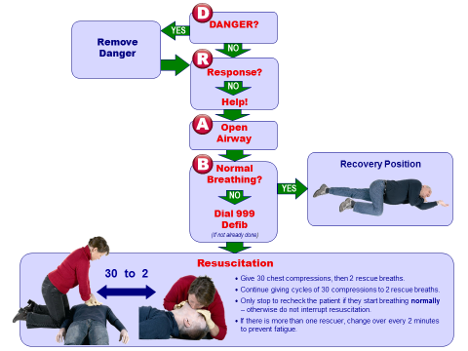

Note: AEDs are located in the bar and foyer of the club and should be used when there is no normal breathing (see chart above). A third AED is available in the vicinity of the Jubilee Bar when open.

Note: The following flow chart is located by the AED and should tell the First Aider how to use it. For children 5 rescue breaths should be given initially.

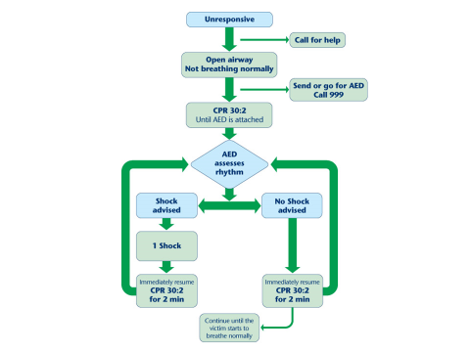

b. Fire Situation:

- Sailor or Instructor brings fire to the attention of the Senior Instructor or Club Staff.
- Senior Instructor ensures the following is done ASAP:
  - Calls Emergency Services on 999, if necessary.
  - Gets the group to a safe place (muster stations) away from the fire and / or building.
  - Accesses the nearest Fire Extinguisher or gets an Instructor to bring this to the location of the fire incident.
  - If safe to do so, extinguishes fire.
- When possible, contacts the parent / guardian / next of kin of course attendees.
- Informs the Principal and makes a record of the incident, assisted by competent persons.

5.3 Emergency Procedures Afloat – See also BYC SOPs.

a. One sailor in difficulty

- Sailor or Instructor brings emergency to the attention of the Senior Instructor
- Senior Instructor does the following:
- Casualty must be immediately brought ashore with another person, unless doing so would incur additional injury of risk.
- Keep a suspected Hypothermia casualty warm.
- If necessary, direct contact should be made with the Coastguard using VHF (IMM Ch16) or other Emergency Services on 999, if necessary, once ashore.
- Follow para 5.2.a for a Medical Incident.
- Put another DI / SI in charge of the remainder of the group with instructions (could be to land boats/boards).
- Contact the parent / guardian / next of kin to debrief on incident and arrange collection, if necessary.

b. Multiple sailors in difficulty

- Sailor or Instructor brings situation to the attention of the Senior Instructor
- Senior Instructor does the following:
- Applies “scoop and run” method, leaving boats with hazard tape, or abandons windsurfers/rigs, checking number abandoned having recovered sailors.
- Coastguard (IMM Ch16) is alerted to situation and asked to call other emergency services if necessary (while still afloat).
- Casualties & all sailors must be immediately brought ashore, unless doing so would incur additional injury of risk.
- Adequate Safety Boats must stay afloat until all sailors are ashore.
- Keep a suspected Hypothermia casualty warm.
- Follow para 5.2.a for a Medical Incident.
- Allocate another instructor in charge of the remainder of the group (one male and one female if applicable and possible).
- Group meets together in Cadet Room, if safe to do so.
- Contact all parents / guardians / next of kin to debrief on incident and arrange collection, if necessary.
- Group briefed on situation where necessary.
- Recover boats, if safe to do so.

5.4 Dealing with a Major Incident

These notes give guidelines in the aftermath of a Major Incident for the SI in charge.

- The priority is the safety of participants and instructors, but once ashore you are going to have to deal with the authorities and the press.

- Get a statement from all competent witnesses.

- Remove the instructor and key witnesses from the club to a place you can talk to them away from the press.

- Produce a written statement in conjunction with the Club Manager, Principal or Duty Executive Officer.

- Don't hold an impromptu press conference.

- Decide who from the club will speak to the media (likely Club Manager or member of the Exec Committee). Inform RYA Training (023 8060 4180) who can assist with compiling your statement to the press. You may wish to contact the RYA’s Communications department on 023 8060 4215 for professional advice on handling the media.

- Don't allow well-meaning but ill-informed persons to make public comments.

- Try to keep a record of whom you have spoken to, who has contacted you etc.

- If the rescue services have been involved the press will have probably obtained some information from them.

- If there has been a fatality, the Police will be involved and inform the next of kin. Do not publicise the name of the casualty until you know this has been done, even if the press appears to know who it is.

- Keep any relevant equipment e.g. Lifejackets, logbooks etc. The Maritime Accident Investigation Branch (MAIB) will require all evidence.

- If required send a report to the MAIB (refer to booklet G27).

- Major accidents at RYA Training Centres are very rare but if you are ever unfortunate enough to be involved in one, it helps if your paperwork is up to date e.g. you have a contact number for the next of kin and that your boats and instructors comply with your own safety policy and the RYA conditions of recognition.

AFTER AN INCIDENT OR NEAR MISS INCIDENT THE ACCIDENT REPORT BOOK IN THE OFFICE MUST BE FILLED IN.

If necessary, there should be a plan for dealing with PTS. This should be briefed to the Exec and Training Committee, with details copied to the RTC Principal. In the case of a staff member, the Line Manager is to be made aware.

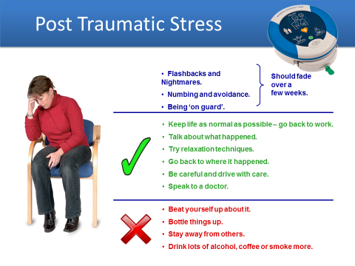

Part B Operating Procedures

1. STATEMENT OF PRINCIPLES

At Ballyholme Yacht Club (BYC), our Officers, staff and members undertake to provide a safe environment for the promotion of organised sailing, boating, diving, and other associated water sports.

Ballyholme Yacht Club recognises its duty under current health and safety legislation and will endeavour to meet the requirements of this legislation and maintain a safe and healthy working environment. Our Officers and staff are informed of their responsibilities to ensure they take all reasonable precautions, to ensure the safety, health, and welfare of those likely to be affected by our activities at BYC.

We recognise our duty, as far as it is practicable, to:
- meet our requirements to maintain safe and healthy working conditions
- provide adequate control of the health and safety risks so identified
- consult with our staff and members on matters affecting their health and safety
- provide and maintain safe plant and equipment
- ensure the safe handling and use of substances
- provide information, instruction, and training where necessary for our staff and members
- ensure that all workers are competent to do their work, and to give them appropriate training if required
- prevent accidents and cases of work-related ill health
- actively manage and supervise health and safety at work
- have access to competent advice
- seek continuous improvement in our health and safety performance and management through regular (at least annually) review and revision of policy; and
- co-operate and work with other employers and their workers, when these workers come onto our premises or sites to do work for us, to ensure the health and safety of everyone at work at BYC.

Doug Rennie
Commodore, BYC
March 2022

2. RESPONSIBILITIES

Whilst overall responsibility for all Club issues rests jointly and severally with the Club Officers, specific health and safety policy responsibilities are delegated as follows:

2.1. General adherence to principles.
It is the responsibility of the Commodore to ensure that the general principles and procedures set out herein are adhered to, to ensure the health and safety of those at risk within BYC.

2.2. Adherence to principles in the provision of RYA training.
It is the responsibility of the RYA Principal to ensure that the principles and procedures related to RYA Sail and Powerboat training courses are adhered to and that sailing equipment is maintained to ensure the health and safety of participants in training at BYC.

2.3. Provision of shore-based facilities and equipment.
It is the responsibility of the Rear-Commodore Shore to ensure that the shore-based facilities, equipment, and procedures, including alarm systems and firefighting equipment, provide a safe environment and are maintained and tested to ensure the health and safety of those at risk within BYC.

2.4. Planning of racing events and general organised afloat activities.
It is the responsibility of the Rear-Commodore Sailing to ensure that the forward planning of racing events and the facilities, equipment and procedures provided for all those involved in organised activities afloat (other than RYA training) are appropriate, effective, and maintained to ensure the health and safety of those on the water at BYC. These responsibilities may be delegated to individual race organisers, organising committees or race officers for specific events at the discretion of the Sailing Committee.

2.5. Planning and organising of diving and related organised activities or procedures.
It is the responsibility of the Diving Officer to ensure that the provision of Club-owned equipment and forward planning and control of organised diving and related organised activities are appropriate and effective to ensure the health and safety of those involved in diving at BYC. These responsibilities may be delegated to individual Dive Marshals for specific events at the discretion of the Diving Officer.

2.6. Provision of rescue equipment and facilities.
It is the responsibility of the Rescue Convener to ensure that the Club’s Safety Boats, facilities, equipment, and procedures providing Safety Boat cover for all those involved in organised activities afloat are appropriate, effective, and adequately maintained to ensure the health and safety of those at risk on the water at BYC. These responsibilities may be delegated to Rescue Maintenance personnel, the Rescue Coordinator, Team Leaders for specified periods or to individual event rescue coordinators for specific events at the discretion of the Sailing Committee.

2.7. Other facilities, equipment, or procedures.
It is the responsibility of the Commodore to specify other named person(s) who shall carry other specific responsibilities for other facilities, equipment or procedures not specified herein to safeguard or improve the safety of those at risk at BYC.

3. PERSONS AT RISK
The following categories of persons must be considered for the mitigation of risk within BYC:

3.1. Those within the vicinity of BYC shore facilities.

Staff
Members
Visitors
Instructors
Course attendees
Contractors
General public

3.2. Those affected by activities afloat, organised by BYC.

Staff
Members
Visitors
Instructors
Course attendees
Other water users

4. IDENTIFICATION OF HAZARDS

The following categories of hazards are deemed to be present within BYC.

4.1 Those within the vicinity of BYC shore facilities:
- Fire
- Hazardous substances
- Tripping / slipping/ falling hazards
- Drowning
- Movement of equipment
- Machinery and tools
- Vehicles
- Electrical hazards
- Marine engines
- Pressurised gas containers
- Gas safety
- Scalding
- Enclosed spaces
- Hazardous waste
- Work at heights
- Lone working
- Display screen equipment
- Food preparation health risks

4.2 Those involved in activities afloat, organised by BYC:
- Fire
- Hazardous substances
- Tripping / slipping hazards
- Drowning
- Movement of Equipment
- Exposure and hypothermia
- Diving-related injuries
- Collisions with other craft
- Marine engines
- Pressurised gas containers

5. MITIGATION OF HAZARDS
The following mitigations of hazards will be used within BYC:

5.1. Those within the vicinity of BYC shore facilities.

5.1.1. Fire.

a. All permanent buildings shall be fitted with fire alarm systems, operated, and tested in accordance with procedure. Adequate, suitable fire extinguishers will be kept in all areas and inspected in accordance with procedure. Potential fire hazards and the presence or build-up of combustible materials will be identified and addressed in accordance with procedure.

b. Awareness of fire procedures will be ensured by adequate, suitably placed signs and in briefings given at the start of all courses and all BYC organised events. Any officer, member or staff bringing contractors onto site shall ensure adequate fire briefing before any work is started.

c. Any contract work that significantly increases fire risk, or involves the use or storage of flammable materials, must be brought to the attention of an officer, who shall instigate such additional measures or procedures necessary to mitigate the increased risk. These measures shall be agreed with the contractor before the start of any works.

d. Marine engine and other fuels shall be stored in suitable containers, kept in the purpose-made fuel store at the Seacliff Roadside of the rescue and training building.

5.1.2. Hazardous substances.

a. A register of COSHH (control of substances hazardous to health) information shall be kept in the office. This information will be updated regularly and shall include handling procedures for regularly used substances. This information will be drawn to the attention of all staff, members and contractors involved in the handling and storage of hazardous substances.

b. Storage of substances will be in separate, designated and suitably marked places. These storage details will be recorded in the COSHH register.

c. An asbestos register shall be kept in the office. This shall record all known asbestos-containing materials present in the club. This information will be drawn to the attention of all staff, members and contractors involved in carrying out works that may potentially impact such materials.

5.1.3. Tripping / slipping / falling hazards.

a. Boat and trailer storage in the north and south boat parks will be managed by the designated parks convener(s) to minimise the risks of tripping. All protruding tie-down points shall be clearly marked. Regular safety inspections of all areas will be carried out in accordance with procedure 7.1.2 to identify and address these hazards.

b. All slipways and jetties will be regularly treated and cleaned to minimise slipping hazards due to algae, rubble etc.

c. A risk of falling from height exists in both the North and South dinghy parks, where there is a possible drop of some 4m at low water. These risks will be briefed at the start of all courses and organised events.

d. The Windsurfing Simulator shall always be used with a mat if on a concrete surface, or used on the lawn, to mitigate injury from falls when conducting training drills. No child under 16 may use the simulator and only instructors are to demonstrate gybes.

5.1.4. Drowning.

Risk of drowning by falling into the sea is present at the shoreline at BYC. All members and staff shall constantly be aware of this risk, and routinely draw it to the attention of visitors, minors etc. Signs shall be erected at the slipways to draw attention to this risk. This shall also be briefed at the start of all courses and organised events.

5.1.5. Movement of equipment.
The risk of personal injury is present when members and staff are involved in the movement of equipment for club functions etc. This risk is increased in the use of the stairs for equipment and stocking of the upstairs bar. This risk shall be brought to the attention of all those involved, and specifically briefed to new members of staff. Course attendees and visitors shall not assist in the movement of equipment. Suitable trolleys shall be provided for movement of large or bulky objects, or multiple objects such as chairs.

5.1.6. Machinery and tools.
The duties involved in the running and upkeep of the club and facilities require the use of machinery and tools that present the risk of personal injury. Duties such as grass cutting, electrical works, engine repairs, etc., shall be carried out by persons specifically designated for such duties and assessed as competent in the use of such equipment. A register of such designations shall be kept in the office. Visitors and course attendees shall not use such equipment.

5.1.7. Vehicles.
The parking of vehicles and the manoeuvring of trailers with vehicles presents the potential risk of personal injury to those present in the boat parks. A speed limit of 5 mph shall be enforced in these areas. All members and staff shall constantly be aware of this risk, and routinely draw it to the attention of visitors, minors etc. Parking will be banned during major events or when large numbers of visitors are present. All persons must be kept clear of vehicles and towlines pulling boats and trailers up slipways. This risk shall be briefed at the start of all courses and organised events.

5.1.8. Electrical hazards.
All electrical equipment shall be regularly inspected and tested for electrical safety by qualified personnel. A register of such testing shall be maintained in the office. All members and staff shall constantly be aware of the risk of damaged or unsafe electrical equipment and shall report all problems to an officer or the office.

5.1.9. Marine engines.
Safety and dive boat engines are routinely run for rinsing and testing in the boat parks. Propeller rotation presents the risk of injury. Engine running out of water shall only be carried out by those holding an RYA powerboat level 2 or equivalent certificate, or under the direct supervision of a Powerboat Instructor. Briefing of this risk shall be included in relevant courses and organised events.

5.1.10. Pressurised gas containers.
All pressurised gas containers shall be regularly tested or replaced in accordance with the relevant regulations. Records for BYC owned cylinders of shall be kept in the office. The Club’s compressor shall be regularly maintained by a competent person and shall only be used by trained operators. Record of use shall be kept in the compressor room.

5.1.11. Signalling devices.
Various sound signalling devices are used within BYC. These shall be kept in a designated secure place in the clubhouse and only used under the direction and personal supervision of a designated competent person.

5.1.12. Scalding.
There are sources of potentially hot water present within the buildings. Regular testing of such sources shall be carried out to guard against excessive water temperatures. Maintenance of mixer valves, thermostats etc. shall be linked to such regular testing. Records of same shall be kept in the office.

5.1.13. Gas Safety

a. Mains gas is provided to four boilers for providing hot water for the showers and taps, and also to the fire in the Lounge Bar. The boilers and fire are serviced and checked on an annual basis by an approved gas maintenance contractor. Records are kept in the Fire File in the General Office.

b. LPG gas is provided to the galley for the cookers and ovens. As per 5.1.13.a.

c. Asphyxiating gases. CO2 cylinders are stored in the beer store. A significant leak and build-up of CO2 in this room could reduce the O2 level in the room to an unsafe level. A CO2 monitor and alarm is provided in the room. This is checked periodically by our beer supplier, Inbev. Records are kept in the Fire File in the General Office.

5.1.14. Enclosed spaces

a. Fuel Store: Petrol and chemicals for slip cleaning are kept in the fuel store, at the roadside of the Rescue Building. Vapours from these could be hazardous, either by depleting the O2 level in the room or by their toxic nature, or by forming an inflammable mixture. To negate these risks, the containers should be kept closed, the room should be well ventilated, and no smoking is allowed in the room. Personnel should not be in the room with the door closed.

b. Running engines inside the Rescue Building can lead to a build-up of CO and CO2, if there was inadequate ventilation due to some or all the doors being closed. Boats should be pulled outside for engine testing/maintenance. Short duration testing inside the Rescue Building can only take place with at least two of the roller doors open.

5.1.15. Hazardous waste
Hazardous waste at the site includes lubricating oil and old diesel oil from engine maintenance, old tins of paint and antifouling, chemical containers, and old cooking oil/fat. These must be collected separately and disposed of at one of the Council’s Recycling Centres.

5.1.16. Working at heights
Where work is to be undertaken at height, it shall be properly planned, appropriately supervised, and carried out in a manner which is safe, so far as it is reasonably practicable. Consideration will be given to the most appropriate means of access, the nature of the work and the suitability of the ground conditions.

5.1.17. Lone working
Given that BYC has a small workforce, there are occasions when a staff member will be working alone in one of the buildings. The nature of the tasks they are being asked to perform needs to be assessed to see if they are at increased risk, due to being a lone worker. This can involve e.g. cash handling or due to health issues.

5.1.18. Display screen equipment
Computers are used by our Office staff and by the Training Manager. Staff using the computers need to be made aware of the control measures to prevent health issues from the use of display equipment for extended durations. These include the chair design and height, screen size and height, lighting (reflections and glare), rest breaks and regular eye-sight tests.

5.1.19. Food Preparation Health Risks
Staff, members, and visitors, who are engaged in the preparation of food and drinks in the Galley, shall be properly briefed on our required hygiene standards and on the correct operation of the Galley equipment. Food handling, preparation, cooking, and storage should be as per the FSA’s Safe Catering Guidelines. Those working in the Galley should be ‘fit for work’ at all times. This means that they must not be suffering from, or carrying, an illness or disease that could cause a problem with food safety. People who are not ‘fit for work’ could spread food poisoning bacteria to food. Anyone who has diarrhoea and/or vomiting must by law report it to their manager immediately and should not return to work until they have had no symptoms for 48 hours.

5.1.20 Manual Handling

a. Manual handling is any transporting or supporting of a load (including the lifting, putting down, pushing, pulling, carrying or moving thereof) by hand or bodily force. As an instructor it is worth being aware that workplace injuries can affect your life and recreation as well as your work, particularly in later years. Injuries sustained while sailing can also affect your students. This includes sudden injuries in the workplace as well as cumulative wear and tear, commonly caused by poor positioning over a period of time. Common risks arise from:
- Excessive or awkward loads for one person.
- Slippery or uneven surfaces
- Repetition or excessive duration of tasks
b. Slipways, jetties and dragging boats can all give rise to these circumstances. Studies show that the overwhelming proportion of accidents in the workplace are sprains or strains due to manual handling. Of these, back injuries are three times more common than any other injury.
The Manual Handling Operations Regulations 1992 contains guidance suggesting that manual handling should be included in risk assessments and that employers, employees and volunteers should take sensible steps to minimise the risks.

c. Handling Tips:
- Widen the base of support whilst lifting/carrying.
- Keep the load inside the base of support whenever possible
- Avoid asymmetry, e.g. carrying a heavy fuel can
- In general, before lifting; ASSESS: task, load, environment, individual(s) PLAN: task, route PREPARE: load, self, area.
- When it comes to moving boats, ensure you have sufficient people to carry out the task safely. For example, pulling a heavy boat up the slipway

5.2. Those involved in activities afloat, organised by BYC.

5.2.1. Fire.
The risk of fire afloat is present on BYC safety and dive boats. All boats shall be subject to regular routine maintenance to address this risk. Smoking and the use of any naked flames shall be banned from all BYC safety and dive boats to mitigate this risk.

5.2.2. Tripping / slipping hazards.
Risks of tripping and slipping whilst afloat aboard BYC-owned powerboats will be addressed by suitable inspection before each launch. This shall be briefed to those involved in launching boats and included in course briefings. Boat floors shall be washed down immediately after any fuel spillage.

5.2.3. Drowning.
The risk of drowning is inherent in all waterborne activities. To minimise this, all organised activities afloat shall include three areas of mitigation:

a. Personal buoyancy or lifejackets. All those afloat aboard safety and dive boats, dinghies, windsurfers and sports boats must at all times wear personal buoyancy to the current recommendations (50N). Other vessels must carry adequate personal buoyancy for all crew. These rules shall be rigorously enforced by all those involved in the organisation of BYC courses and organised events.

b. Provision of Safety Boat cover. Competitors can reasonably expect Safety Boat cover for all organised dinghy events. Courses also require adequate Safety Boat provisions. Suitably fitted and crewed Safety Boat cover will at all times be provided such that any vessel can be reached within approximately 3 minutes of an occurrence during an organised event. A BYC member holding an RYA Level 2 powerboat certificate or equivalent shall be in charge of each Safety Boat. BYC Safety Boats shall be operated and maintained in accordance with the procedures 6.7 and 6.8 in section 6 of this document.

c. Consideration of current and expected weather conditions. All those involved in organising and controlling afloat activities shall take account of the current and imminent weather conditions in respect of the abilities and preparedness of those involved. A nominated person, normally the Race Officer, Dive Marshal or Senior Instructor, will assess the conditions prior to each session afloat and curtail or stop activities if weather conditions present an unacceptable level of risk.

5.2.4. Movement of equipment
The risk of personal injury is present when members are involved in the movement of equipment when afloat (e.g. lifting & recovering marks). These risks shall be brought to the attention of all those involved. Course attendees and visitors shall not assist in these activities.

5.2.5. Exposure and hypothermia.
The comments in 5.2.3 above also apply to the mitigation of these risks. In addition, race/dive organisers and instructors will ensure that all those going afloat will be briefed at the start of all courses and organised events.

5.2.7. Diving-related injuries
All diving shall be carried out in accordance with the BSAC Safe Diving Practices. In the event of a diving-related injury occurring, the Dive Marshal shall assess the situation, advise the Coastguard where appropriate (via VHF), and arrange for suitable treatment. Any such injuries should be reported at the earliest opportunity to the Diving Officer, and to the Club Officers after subsequent investigation, and to the BSAC if necessary.

5.2.8. Collisions with other craft.

a. The risk of collision with other craft exists during all organised afloat activities. All BYC boats shall comply with the International Regulations for Preventing Collisions at Sea, except for sailing boats whilst racing, where they shall comply with the Racing Rules of Sailing.

b. Safety Boats, dive boats and race official boats must be aware of the risk both between boats directly involved in their activities and other water users. BYC boats must always be helmed either by competent members or specifically designated visitors holding an RYA powerboat level 2 or BSAC Diver Coxswain qualification, or under the direct supervision of a Powerboat Instructor. Briefing of this risk shall be included in relevant courses.

5.2.9. Marine engines.
The risk of injury from marine engines whilst afloat is addressed by adequate training and the use of kill cords on all BYC powerboats. Kill cords shall be worn by Safety Boat helms at all times, except when the engine is stopped for rescue work. Kill cords shall be tested at each launch. Boats shall at all times be under the control of a competent member or specifically designated visitor holding an RYA powerboat level 2 or BSAC Diver Coxswain qualification.

5.2.10. Pressurised gas containers.
Gas cylinders shall be adequately secured in boats when afloat, to avoid damage to the cylinder and/or pillar valve.

6. OPERATING PROCEDURES

6.1. Safety equipment and inspections ashore.

6.1.1. Fire equipment.

a. Fire alarm systems shall be tested monthly prior to each Shore Committee meeting. A log of the systems to be tested, date of testing, tester, and condition found, and any remedial work shall be maintained in the office. This log shall be reported at each Shore Committee meeting. Any problems shall be immediately reported to an officer for action. All systems shall be the subject of annual inspections by the supplier or other designated specialist contractor. At least one alarm test per year shall be carried out during a club function, or when enough members are present, to raise awareness of the alarm system operation.

b. Firefighting equipment shall be inspected every three months during the shore safety inspection. Firefighting equipment shall be thoroughly inspected and serviced or replaced annually by the supplier or other designated specialist contractor. A log of firefighting equipment shall be maintained in the office.
Fire awareness training should take place on an annual basis for all employees and recorded.

6.1.2. Shore safety inspection.
All BYC shore facilities shall be subject to regular safety inspection tours, known as “Shore Safety Inspections”.

a. The Shore Safety Inspection shall be carried out by a minimum of three members, at least one of which shall be a designated Shore Committee Officer. The inspection shall address all potential persons at risk and categories of risks indicated in the BYC Health and Safety policy document. Potential fire hazards and the presence or build-up of combustible materials will be identified and addressed. Safe storage of fuels, hazardous substances, tripping and slipping hazards, and the condition of walkways and slipways shall be assessed and recorded. It shall also address any additional risks not previously identified or inappropriate measures; this shall be used as the means to update this document as required.

b. A record of inspections shall be kept showing route of inspection, problems found, date of inspection, those present and any remedial works. This shall be maintained in the office. This record shall be reported to the Shore Committee meeting, where follow up actions shall be progressed.

6.2. Safety equipment and inspections afloat.

6.2.1. Sailing equipment inspections.
All sailing equipment shall be inspected annually by the RYA Principal. In addition, all relevant sailing equipment shall be inspected by the Senior Instructor designated for a particular course prior to the start of each course. The RTC is also inspected annually by an external independent Trainer on behalf of the RYA.

6.2.2. Safety Boat inspections.
All power boats and engines shall be serviced, inspected, and recorded by a designated specialist at least twice per season. Condition reports shall be made to the Sailing Committee and / or Dive Committee. In addition, the Convener, Team Leader, Dive Marshal, or other designated rescue controller shall inspect each boat for safety equipment prior to each launch.

6.2.3. Safety Afloat Audit.
All BYC afloat safety equipment, procedures and planning shall be subject to an annual safety audit, known as the “Safety Afloat Audit”.
a. The audit shall be carried out at least annually by a minimum of three members, at least one of which shall be a designated Sailing Committee Officer. The audit shall address all potential persons at risk and categories of risks indicated in the BYC Health and Safety policy document. Opportunity shall be taken to review the use of equipment, procedures and planning for events since the last audit to measure successful mitigation of hazards. It shall also address any additional risks not previously identified or inappropriate measures; this shall be used as the means to update this document as required.

b. This audit shall be reported at the Sailing Committee meeting, where follow up actions shall be progressed.

6.3. Generic course operating framework.

6.3.1. Course preparation and attendee registration.

a. A Senior Instructor (SI), or equivalent, shall be appointed for each course. They shall assume responsibility for planning for the course, including adherence to the principles herein. All operations should have a Risk Assessment available, and this should be shown to the Senior Instructor prior to any course running.

b. Briefings of additional risks shall be sought from a Club Officer prior to the start of a course. Requirements for other instructors and Safety Boat cover shall be determined and recorded prior to the start of a course by the RYA Principal and agreed to by the SI after discussion.

c. All attendees shall provide information on medical conditions and shore contacts as part of registration for the course. This must be reviewed by the SI before the start of the course. Any resultant special arrangements or provisions must be briefed to all instructors, assistants, and safety crew.

6.3.2. Course ashore briefings and sessions.

a. A briefing for dinghy instructors is necessary prior to the arrival of the course participants. For summer courses this is at 9am on Mondays and 9.15 on Tuesday to Fridays.

b. Courses may consist of either or both ashore and afloat sessions. An initial ashore safety briefing shall be provided to all course attendees at the start of the first session, regardless of the need for other ashore sessions.

c. Briefings must include:
- Fire alarms, procedures, telephone points and availability of First Aid.
- Tripping and slipping hazards in the boat parks, on slipways and jetties.
- Use of Windsurfing Simulator (if applicable)
- Risks from the wash of ferries.
- Risks from vehicle movements in the boat parks including towing up slipways.
- Risks from marine engines where appropriate.
- Use of personal buoyancy.
- Provision of suitable personal clothing and where to stow this after use.
- Location of the galley for lunch.
- Location of changing areas and notice about their cleanliness.
- Notice on the use of the wet entrances to the changing areas.
- Introduction to the other staff at the club.
- Notice about course rules and course procedures.
- Safe operation and mooring of Safety Boats.
- Any specific additional risks identified and not addressed at previous safety inspections.
d. A copy of the course rules and procedures are available from the RYA Principal.

6.3.3. Course afloat briefings and sessions.

a. Other than those briefings included above, an additional briefing shall be provided immediately prior to each afloat session.

b. This must include:

- Current and expected weather conditions.
- Provision of suitable personal clothing.
- Likelihood of abandonment or cancellation.
- Method of indicating return ashore.
- Method of being accounted for at the return ashore.
- Safety cover.

c. A session debrief must be done as soon as possible after the course participants have come ashore.

d. Accidents and incidents must be noted in the report book.

e. All afloat instructors shall also be briefed in methods of communication with the SI and requirements for reporting of deteriorating conditions.

6.4. Feedback Procedure.

Feedback forms will be given to each course participant at the end of the course. Forms will be returned to chief instructor, read and appropriate action will be taken according to information obtained from feedback.
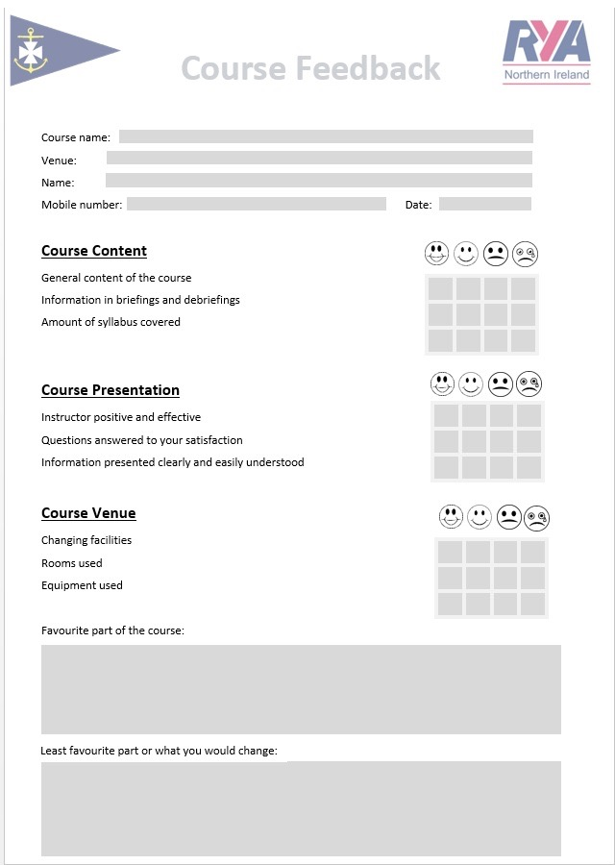

6.5. Evacuation procedure.
a. Anyone present within the shore facilities at BYC shall be aware of the mechanisms and means of safe escape from buildings. The evacuation procedure shall be briefed at the start of courses and organised events.

b. Anyone detecting a fire shall immediately raise the alarm. The alarm is a continuously ringing bell. Emergency services should be contacted by telephone using 999. Evacuation from the building shall be via the marked emergency escape routes to the primary designated muster point in the North Boat Park, or to the alternative muster point in the South Park, if necessary. Small fires should only be tackled by a competent person, using the extinguishers provided.
The use of fire extinguishers, etc shall be reported to a club officer or member of staff.

6.6. Emergency procedure ashore.

a. Anyone present within the shore facilities at BYC shall be made aware of the provision of First Aid and conduct during medical emergencies. This shall be displayed on notices and briefed at the start of courses and organised events. All course attendees shall be made aware of available first aiders and facilities.

b. Anyone seeing or finding someone taken ill or hurt, or a fire, shall immediately get First Aid help and / or contact the emergency services. Medical emergencies shall be reported to a club officer or staff, who can contact 999 if not already done. Minor medical emergencies can utilise the First Aid equipment available in the office, bar, or rescue building.

6.7. Emergency procedure afloat.

a. Anyone going afloat at BYC shall be aware of the means of reacting to emergencies on the water. A specific procedure shall apply for each course or event. For all RYA courses the course Senior Instructor shall be designated as the duty First Aider; however, every RYA instructor needs to have an in-date RYA recognised First Aid certificate, which shall be updated every three years. The emergency afloat procedure shall be covered at the start of courses and organised events.

b. Anyone becoming aware of an emergency afloat shall immediately raise the alarm by informing a Safety Boat and/or contacting the battery or clubhouse. If necessary, direct contact should be made with the coastguard using telephone or preferably VHF. Injured persons must be immediately brought ashore unless doing so would incur additional injury or risk.

c. Hypothermia is a particular risk. Anyone who has been immersed for a significant time must immediately be covered with a blanket or warm clothing and brought ashore for treatment. A hypothermia case will require medical treatment, so the emergency services should be contacted on 999 ASAP.

d. Minor medical emergencies can utilise First Aid equipment available in the Safety Boats, the rescue building or the clubhouse office or bar. In the case of head injuries, ice packs are available in the galley and the bar.

6.8. Safety Boat operational procedure.

a. The provision of adequate Safety Boat cover to ensure safety for both dinghy events and courses is dependent on the condition and safe operation of the Safety Boats. BYC Safety Boats shall therefore only be operated under the direction of a person holding a minimum of the RYA “Powerboat Level 2” certificate, with at least one additional competent crew.
b. The use of BYC Safety Boats shall adhere to the following guidelines:

- Safety Boat keys are to be kept locked in the Battery when not in use.
- Safety Boats shall have on board a waterproof safety box containing all safety related items.
- Safety Boats waterproof boxes shall be checked to be dry and complete prior to launch.
- Safety Boat trailers/trolleys shall be checked for safe operational condition prior to launch.
- Safety Boats shall be checked for fuel, condition, and safe operation prior to launch.
- Safety Boat engines shall be run prior to launch.
- Safety Boat kill cords shall be tested prior to launch.
- Safety Boats shall carry out a VHF radio check immediately after launch.
- Safety Boats shall stay afloat and manned until the last competitor or course attendee is ashore.
- Safety Boats shall be moored in a safe manner to avoid damage, with particular care being taken to avoid boats passing under the jetty, either by mooring on the lee side of the jetty or by use of the haul-out line when in place; this item is to be included in all pre-course briefs.
- Safety Boats shall be retrieved with engines partially raised to guard against propeller damage.
- Safety Boat engines shall be run using freshwater for a minimum of 3 minutes after recovery.
- Safety Boats shall be washed down, cleaned and emptied of rubbish after use.
- Waterproof safety boxes shall be checked to be dry and complete after use and returned to the Battery.
- Any problems or faults shall be recorded in the Standard Operating Procedures Register in the Battery or related directly to the Rescue Convener or Safety Boat maintenance personnel, immediately after recovery.
c. Waterproof safety boxes shall contain as a minimum the following:

- 2 red pinpoint flares in date
- 2 orange smokes in date
- 1 sealed First Aid pack of adequate size
- 1 toolkit for the engine in use
- 1 space blanket
- 1 spare kill cord
- 1 spare starter rope
- 1 handheld compass (unless the boat is fitted with a fixed compass)
- 1 fire-extinguisher
- 1 knife (unless there is a safety knife/holster attached to the console)

d. Each Safety Boat shall also carry the following equipment:

- 1 anchor and adequate warp stored in a dedicated locker, console or seat storage
- 1 internal anchor attachment point
- 1 baler fitted to the transom
- 1 alternate baler or bucket
- 2 warps of at least 10 meters
- 1 painter attached to the bow that cannot reach the propeller
- 1 console mounted VHF radio or handheld radio held in a dedicated pouch
- 1 collar inflation pump or bellows with correct hose and end fitting

e. These lists shall be prominently displayed in the Rescue Shed.

6.9. Safety Boat maintenance procedure.

a. The provision of adequate Safety Boat cover to ensure safety for both dinghy events and courses is also dependent on the reliable operational condition of the Safety Boats. BYC Safety Boats shall therefore be subject to routine maintenance and regular inspection by the Rescue Convener, BYC designated Safety Boat maintenance personnel or designated specialist.

b. The maintenance of BYC Safety Boats shall adhere to the following guidelines:
Six monthly:

- Safety Boat hulls, collars shall be thoroughly checked for condition.
- Safety Boat engines shall be serviced by a designated specialist.
- Records of such services shall be held both by the specialist and BYC
Monthly:
- Safety Boat kill cords shall be tested for safe operation and condition.
- Safety Boat VHF radios shall be checked for correct operation.
- Safety Boats engine oil levels and quality shall be checked.
- Safety Boat propellers shall be thoroughly checked and if necessary, returned to the designated specialist for repair or replacement.
- Safety Boats shall be launched and tested for safe and correct operation by the Rescue Convener or Safety Boat maintenance personnel.
- Safety Boats shall be returned to the specialist if any significant problems are found or reported.
- Waterproof safety boxes shall be checked to be dry and complete.
d. Any problems or faults recorded in the Standard Operating Procedures Register in the Battery, or related directly to the Rescue Convener or Safety Boat maintenance personnel, shall be acted on prior to the next planned use of the boat, either by rectification, return to the designated specialist or by clearly marking the boat as “Out of Service” with a suitable label mechanism e.g. Out Of Service wheel-cover or prop-bag.

