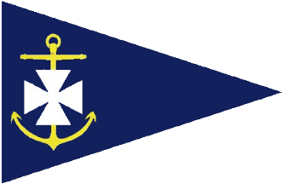

Ballyholme Yacht Club

50th Anniversary – Laser Class Race Day
Saturday 25th September 2021

Amendment to Notice of Race

4. Eligibility and Entry now includes:

4.3 Entry for the event closes at 1200 hrs on Friday 24th September 2021. No late entries will be permitted to participate in the event.

Aidan Pounder

