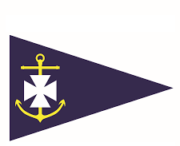
Volunteer Role Title | Volunteer Caretaker
Main Point of Contact | Club Manager
Commitment | Up to 10 hours per week. There are no fixed hours/days for this role so it can be flexible to suit.

Ballyholme Yacht Club is the premier dinghy racing club in Northern Ireland. We are the home of champions and new sailors alike. We are run by members, for our members, encouraging sailing, stand up paddle boarding, sea swimming, kayaking, diving, and social events. We rely on the support of volunteers to continue to provide top quality facilities, activities and events and we are now looking for a Volunteer Caretaker.
If you have an interest in grounds and property maintenance, have some skills in basic DIY, gardening and maintenance then this may be the role for you!

Tasks:
- Open and closing the building
- Preparing the rooms for training sessions and meetings
- Basic maintenance of the building
- Grounds maintenance and light gardening
- Liaising with gas, electricity and fire alarm companies when they visit
Skill and Qualifications Required:
- Experience in grounds and building maintenance, gardening and DIY
Areas of Interest:
Water sports, gardening, maintenance, local sports clubs

Home based opportunity: No
DBS Check Required: No
Opportunity Accessibility: Accessible toilets

Come and join our family of volunteers at Ballyholme Yacht Club today! For more information please email your interest to clubmanager@ballyholme.com

