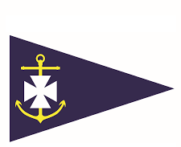
Volunteer Role Title | Digital Content Creator - Volunteer
Main Point of Contact | Club Manager
Commitment | Flexible hours to suit

Ballyholme Yacht Club is the premier dinghy racing club in Northern Ireland. We are the home of champions and new sailors alike. We are run by members, for our members, encouraging sailing, stand up paddle boarding, sea swimming, kayaking, diving, and social events. We rely on the support of volunteers to continue to provide top quality facilities, activities and events and we are now looking for a Web Content Creator.
Are you looking to develop your skills, learn new skills or use existing skills? We need someone who can identify, create, manage and deliver digital content on our website, social media channels and email bulletins.
Tasks:
- Writing, reviewing, editing, and updating content for our website
- Regularly promoting activities, events and news on social media channels
- Monitoring social media and company website metrics.
- Utilizing SEO methods to increase site traffic.
- Suggesting new ways to promote BYC to new members and certain events to current members
Skill and Qualifications Required:

- Experience in writing engaging content
- The ability to work independently and remotely

Areas of Interest:
Water sports, writing, digital platforms, social media, local sports clubs

Home based opportunity: Yes
DBS Check Required: No
Opportunity Accessibility: Accessible toilets

Come and join our family of volunteers at Ballyholme Yacht Club today! For more information please email your interest to clubmanager@ballyholme.com

