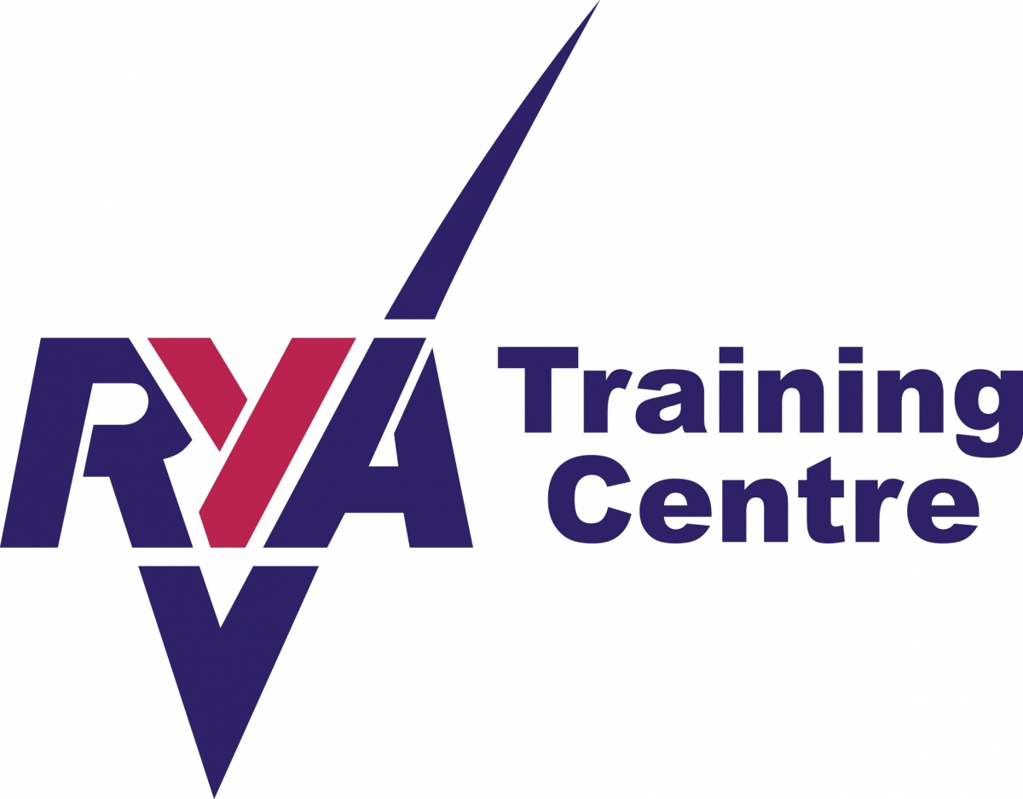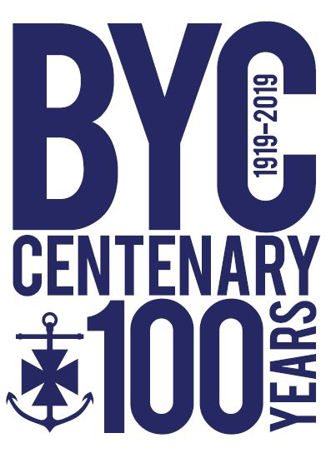

RYA Dinghy Senior Instructor (SI)

BYC Application Form Summer 2021

Please fill in the form completely, carefully and accurately. It will assist your application.
Please complete and return this form electronically to: admin@ballyholme.com
About you:
SURNAME: | FORENAME:
DOB: | NATIONAL INS. No:  Or  Country of citizenship equivalent:
EMAIL:
MOBILE No.:
Emergency Contact’s name & mobile no.:
ADDRESS:

POSTCODE:
MEDICAL CONDITIONS: (if applicable)

DOCTOR’S NAME:
ADDRESS:

TEL:
BYC MEMBER Yes / No

Your instructing qualifications
** You should include a scan copy of all your certificates
ACCESS NI CERTIFICATE YES/NO  (16 years and over) | No.
FIRST AID CERTIFICATE: Date
POWERBOAT LEVEL 2: Date
SAFETY BOAT: Date
ASSISTANT INSTRUCTOR: Date
DINGHY INSTRUCTOR: Date
SENIOR INSTRUCTOR: Date
RACE COACH (LEVEL 2): Date
SAFE AND FUN: Date

Your instructing past
RYA INSTRUCTING EXPERIENCE- please give examples.

DATES | WHERE | LEVEL OF INSTRUCTOR (SI,DI,AI)  TYPE OF COURSE YOUTH/ADULT

Your other instructing and sailing experiences
OTHER INSTRUCTING OR COACHING YOU HAVE DONE:

SAILING EXPERIENCES /ACHIEVEMENTS:

Dates You are unavailable in June, July or August

ANYTHING YOU MIGHT LIKE TO ADD:

Declaration
I AM AWARE OF BYC CHILD SAFEGUARDING & PROTECTION POLICY: YES/NO
I AM AWARE OF BYC STANDARD OPERATING PROCEEDURE: YES/N0
I AM AWARE OF BYC CODE OF CONDUCT FOR INSTRUCTORS: YES/NO
Please give names and contact details of two referees:
- _____________________________ ________________________________
- _____________________________ ________________________________

SIGNED DATE

