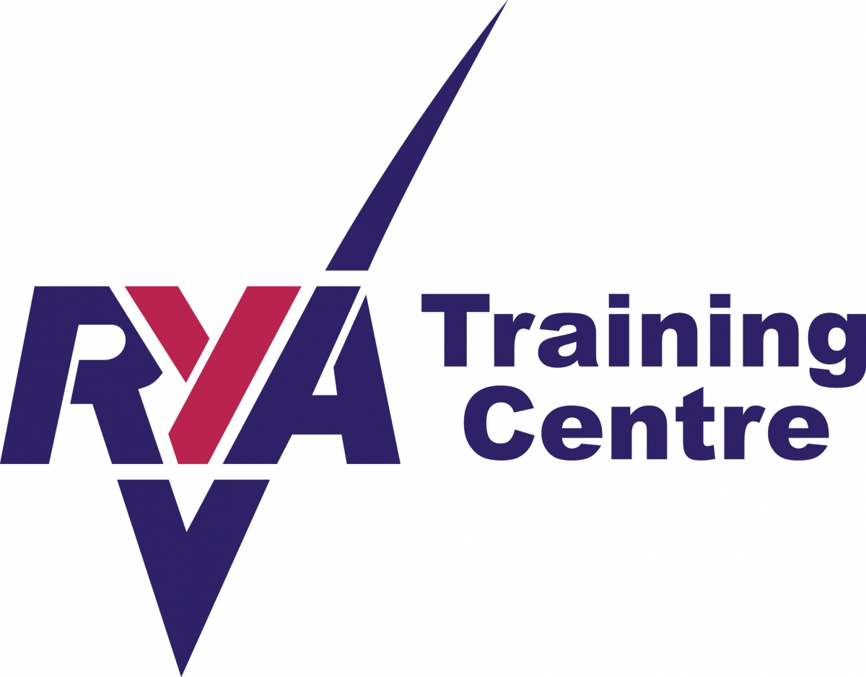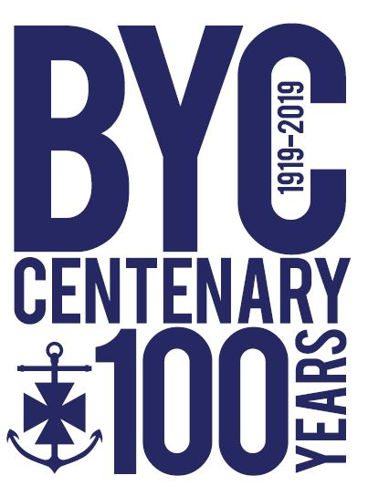

Sailing Instructor (AI, DI or SI)

BYC Application Form 2019

Please fill in the form completely, carefully and accurately. It will assist your application.
We would prefer for you to complete and return this electronically.
Return by email to: admin@ballyholme.com or by hand.
About you:
SURNAME: | FORENAME:
DOB: | NATIONAL INS. No.
EMAIL:
MOBILE No.:
Emergency Contact’s name & mobile no.:
ADDRESS:

POSTCODE:
MEDICAL CONDITIONS: (if applicable)

DOCTOR’S NAME:
ADDRESS:

TEL:
BYC MEMBER Yes / No

Your instructing qualifications
** You should include a scan copy of all your certificates
ACCESS NI CERTIFICATE YES/NO  (16 years and over) | No.
FIRST AID CERTIFICATE: Date
POWERBOAT LEVEL 2: Date
SAFETY BOAT: Date
ASSISTANT INSTRUCTOR: Date
DINGHY INSTRUCTOR: Date
SENIOR INSTRUCTOR: Date
RACE COACH (LEVEL 2): Date
SAFE AND FUN: Date

Your instructing past
INSTRUCTING EXPERIENCE

DATES | WHERE | LEVEL OF INSTRUCTOR (SI,DI,AI)  TYPE OF COURSE YOUTH/ADULT

Your other instructing and sailing experiences
OTHER INSTRUCTING OR COACHING YOU HAVE DONE:

BEST SAILING EXPERIENCES / HIGHEST ACHIEVEMENTS:

Your availability
PROVISIONAL COURSE DATES | AVAILABLE YES/NO
6th/7th April: RYA L1/L2 SERC Bangor
4th May: RYA Push the Boat Out (volunteering)
Tues 7th,14th 21st, 28th May:
Women on Water (evenings)
Tues 4th, 11th, 18th, 25th June, July 2nd Adult Training (evenings)
3rd-7th June: RYA SS1/SS2 Kilcooley PS (daytime)
1st- 5th July: RYA SS1/SS2 summer course (daytime)
8th – 12th July RYA SS1/SS2 summer course (daytime)
15th-19th July: RYA Start Racing summer course (daytime)
22nd – 26th July: RYA SS3/SS4 summer course (daytime)
29th July- 2nd August: Seamanship/spinnakers/day sailing (daytime)
3rd -4th August: RYA Adult L1/L2 course (daytime)
Tues 6th, 13th, 20th, 27th August, Sept 3rd: Adult Training (evening)
5th- 9th August RYA: SS1/ SS2 summer course (daytime)
12th -16th August: RYA SS3/SS4 summer course (daytime)

ANYTHING YOU MIGHT LIKE TO ADD:

Declaration
I AM AWARE OF BYC CHILD SAFEGUARDING & PROTECTION POLICY: YES/NO
I AM AWARE OF BYC STANDARD OPERATING PROCEEDURE: YES/N0
I AM AWARE OF BYC CODE OF CONDUCT FOR INSTRUCTORS: YES/NO
SIGNED DATE

