BALLYHOLME YACHT CLUB & ROYAL ULSTER YACHT CLUB

Sailing Instructions

for the

LUFRA CUP MENAGERIE RACE

SATURDAY 7th SEPTEMBER 2019

The Lufra Cup Menagerie Race is a pursuit handicap race. Entry forms are posted on the BYC, RUYC and Bangor Marina notice boards. Entry closes on Friday 6th at 1200.

1. RULES
1.1 The race will be governed by the rules as defined in The Racing Rules of Sailing (RRS).
1.2 The prescriptions of the RYA will apply
1.3 Racing rules 25, 26, 29.1, A4, A5, 35, 40, 60.1(a), 63.1 will be changed. The changes appear in full in these sailing instructions.

2. NOTICES TO COMPETITORS
Notices to competitors will be posted on a notice board at Bangor Marina and at the front door of Ballyholme Yacht Club.

3. CHANGES TO SAILING INSTRUCTIONS
Any change to the Sailing Instructions will be posted before 12:00 on the day of the race on the front door of Ballyholme Yacht Club.

4. SIGNALS MADE ASHORE
4.1 Signals made ashore will be displayed at Ballyholme Yacht Club.
4.2 When flag AP is displayed ashore, ‘1 minute’ is replaced with ‘not less than 30 minutes’ in the race signal AP.

5. SCHEDULE OF RACE
5.1 The scheduled time of the Warning Signal for the first class to start is 13:24.
5.2 Starting times, class flags (and any related instructions) will be posted on the BYC Front Door no later than 1830hr on Friday 6th September 2019. A copy will also be posted on the BYC Notice Board in the Marina and at RUYC.

6. THE COURSE
6.1 The course will be a windward/leeward course, using three yellow marks (see Attachment 1). The course (A or B) will be identified on a blackboard at the stern of the Committee boat.
6.2 The Topper Class will complete one lap of the course only and will then finish at the Committee boat, as shown by the red arrow in Attachment 1. All other boats should continue sailing around Marks 1, 2, & 3 until their finish.

7. THE START
7.1 The starting line will be between an Orange mast on the committee boat displaying an orange flag at the starboard end and the green port-end starting mark.
7.2 RRS 26 will not apply. The Warning and Preparatory Signals for the first Start will be made at three minute intervals, followed by Starting Signals for other Classes as indicated in the schedule of SI 5.2 above. After the first Preparatory Signal, Flag "P" will be displayed continuously; the Preparatory Signal for the immediately preceding Class will be the Warning Signal for the next Class, and the displaying of the Class Flag shall be the Preparatory Signal for that Class. In the context of this Sailing Instruction (SI), the expression "Class" means all and any individual boats and Classes given a particular start time in the schedule of SI 5.2.
7.3 In amendment of RRS 29.1, Flag “X” only will be displayed as appropriate for a maximum of thirty seconds. Otherwise it is the responsibility of each boat to ensure that she has complied with the starting procedure.

8. THE FINISH
8.1 The Finishing Line for all boats, except the Toppers, will be set at approximately 15:30 and will be between a Committee Boat (RIB) flying a blue flag and a red mark, set along the leg of the course being sailed by the lead boat(s).
8.2 The Finishing Signal will be Flag "S" and will be displayed from the Committee Boat. In amendment of RRS 25 and Race Signals, no sound signal will be made when the signal is displayed.

9. TIME LIMITS
Boats failing to finish within 30 minutes after the first boat sails the course and finishes will be scored Did Not Finish. This changes RRS 35 and A4.

10. PROTESTS AND REQUESTS FOR REDRESS
10.1 Protest time is 90 minutes after the finish time of the last boat to finish.
10.2 Protest forms are available at Ballyholme Yacht Club. Protests and requests for redress shall be delivered there within Protest Time.
10.3 Notices will be posted no later than 2 days after the protest time limit to inform competitors of hearings in which they are parties or named as witnesses. Hearings will be held in the protest committee room, located at Ballyholme Yacht Club.
10.5 Notices of protests by the race committee or protest committee will be posted to inform boats under RRS 61.1(b).
10.6 Breaches of Sailing Instruction 14 will not be grounds for a protest by a boat. This changes Rule 60.1(a). Penalties for these breaches may be less than disqualification if the protest committee so decides.

11. RADIO COMMUNICATION
Except in an emergency, a boat that is racing shall not make voice or data transmissions and shall not receive voice or data communication that is not available to all boats.

12. PRIZES
Prizes will be given as follows (Prizes will be awarded at the BYC Annual Prize Giving):

12.1 The Lufra Cup is given to the Overall Winner (first finisher)
12.2 First BYC Cruiser (Bob Waterson Cup)
12.3 First Waverley (60th Anniversary Cup)
12.4 First Dinghy
12.5 First Topper

13. RISK STATEMENT
Rule 4 of the Racing Rules of Sailing states: “The responsibility for a boat’s decision to participate in a race or to continue racing is hers alone.” Sailing is by its nature an unpredictable sport and therefore involves an element of risk. By taking part in the event, each competitor agrees and acknowledges that:
a) They are aware of the inherent element of risk involved in the sport and accept responsibility for the exposure of themselves, their crew and their boat to such inherent risk whilst taking part in the event;
b) They are responsible for the safety of themselves, their crew, their boat and their other property whether afloat or ashore;
c) They accept responsibility for any injury, damage or loss to the extent caused by their own actions or omissions;
d) Their boat is in good order, equipped to sail in the event and they are fit to participate;
e) The provision of a race management team, patrol boats, umpires and other officials and volunteers by the organiser does not relieve them of their own responsibilities;
f) The provision of patrol boat cover is limited to such assistance, particularly in extreme weather conditions, as can be practically provided in the circumstances;
g) It is their responsibility to familiarise themselves with any risks specific to this venue or this event drawn to their attention in any rules and information produced for the venue or event and to attend any safety briefing held for the event.

14. SAFETY
14.1 Dinghies and Multihulls shall carry an adequate towing warp, at least three metres in length, secured to a strong point at all times.
14.2 In amendment of RRS 40, each person sailing in Dinghy or Multihull Classes shall wear adequate personal buoyancy at all times when afloat.
14.3 NHC Keelboats shall comply with ORC Special Regulations Category 4 and anchors are not allowed to be stowed projecting forward of the bow. All other keelboats shall carry a bilge pump, a bucket, an anchor and line, a compass, a life jacket complete with whistle for each crewmember.

15. INSURANCE
Each participating boat shall be insured with valid third-party liability insurance with a minimum cover of £3,000,000.00 per incident or the equivalent.

16. ENTRY FEE
There will be an entry fee of £2.00 per person (at least!) and all proceeds go to the RNLI. This will be collected in the BYC Bar after the race.

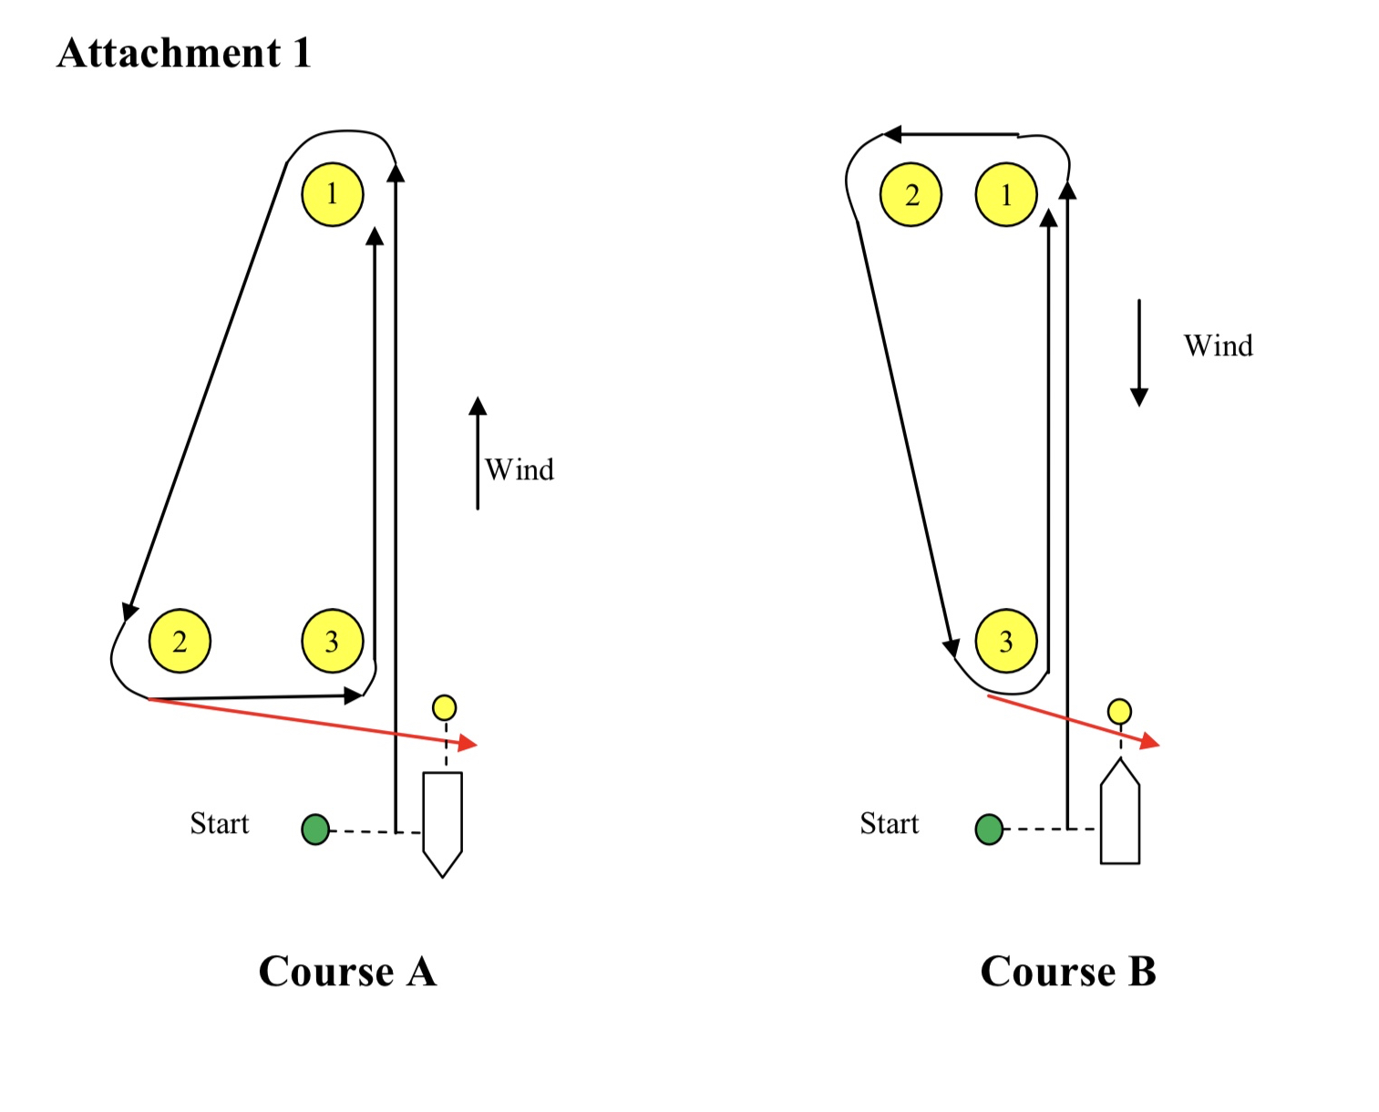
The Topper Class will complete one lap only and will finish between the Committee Boat and a small mark (shown yellow in the diagram) either in front of or astern of the Committee Boat, as shown with the red arrow in Course A and B above.

All other boats will continue to sail around the yellow marks (1, 2 and 3), as described in SI 6.

